A PACE Simulator Based on the GEOS-5 Earth System Model
with Application to Atmospheric Correction
Gregg, Watson W. (GSFC-6101)

Principal Investigator: | Arlindo da Silva (NASA/GSFC)
Co-Investigators: | Watson Gregg (NASA/GSFC)
Collaborators: | Cecile Rousseaux (GESTAR/USRA)  William Putman (NASA/GSFC)

A Proposal Submitted to:

NASA Research Announcement NNH13ZDA001N-PACEST
PACE Science Team

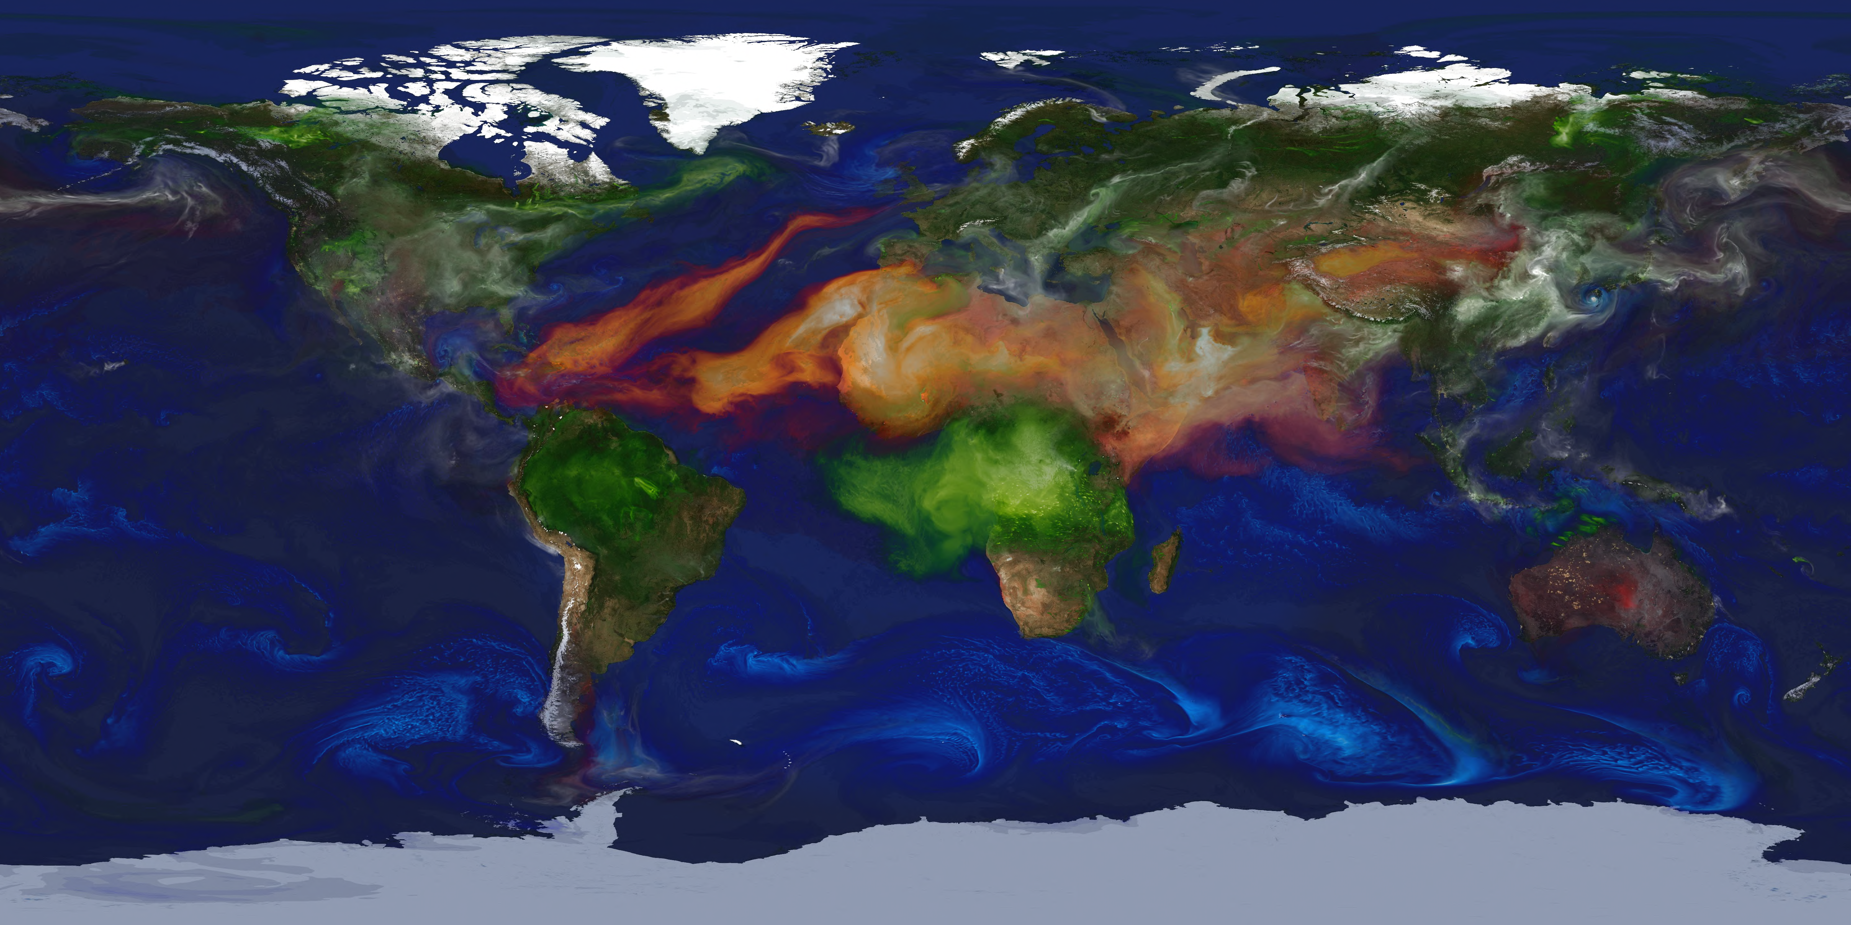

March 2014

Table of Contents
Executive Summary ii
Scientific / Technical / Management 1
1 Technical Approach and Methodology 1
1.1 Objectives and Expected Significance 1
1.1.1 Main Objectives of This Proposal 1
1.1.2 Relevance to NASA Program Elements 1
1.2 Implementation: Building on Existing Capabilities 1
1.2.1 GEOS-5 Earth Modeling System: Overview 1
1.2.2 Aerosols in GEOS-5 1
1.2.3 The NOBM Ocean Bio-geochemical Component 1
1.2.4 The GEOS-5 Global Mesoscale Simulation 1
1.2.5 Radiative Transfer models: VLIDORT and OASIM 1
1.2.6 GEOS-5 OSSE Capabilities 1
1.2.7 The Nominal PACE Radiometer and Orbit 1
1.2.8 Atmospheric Correction Retrieval Algorithm 1
1.2 Research and Analysis Plan 2
Task 1: High Resolution Ocean Bio-chemical Simulation 2
Task 2: Level 2 Simulator: Meteorology, Clouds, Aerosols and Ocean Characteristics 2
Task 3: Level 1 Simulator: Water Leaving and Top-of-atmosphere Reflectances 2
Task 4: Assessing Atmospheric Correction Strategies 2
2 Impact of Proposed Work 2
3 Plan of Work 2
3.1 Key Milestones 2
3.2 Management Structure & Personnel Responsibility 2
3.3 Leveraging 2
4 Data Sharing Plan 3
References 4
List of Acronyms 5
Biographical Sketches 6
Current and Pending Funding 7
Budget Justification: Narrative and Details 8

Executive Summary
A model-based Observing System Simulation Experiment (OSSE) is a framework for numerical experimentation in which observables are simulated from fields generated by an earth system model, including a parameterized description of observational error characteristics. Simulated observations can be used for sampling studies, quantifying errors in analysis or retrieval algorithms, and ultimately being a planning tool for designing new observing missions. While this framework has traditionally been used to assess the impact of observations on numerical weather prediction, it has a much broader applicability, in particular to aerosols, chemical constituents and ocean bio-geochemical properties.
The main goal of this proposal is to extend the GEOS-5 OSSE capabilities being developed at GMAO to ocean bio-chemical parameters relevant to the Pre-Aerosol, Cloud, ocean Ecosystem (PACE) mission. As such it leverages latest developments in the GEOS-5 modeling capabilities, observation error characterization and a rigorous OSSE methodology.

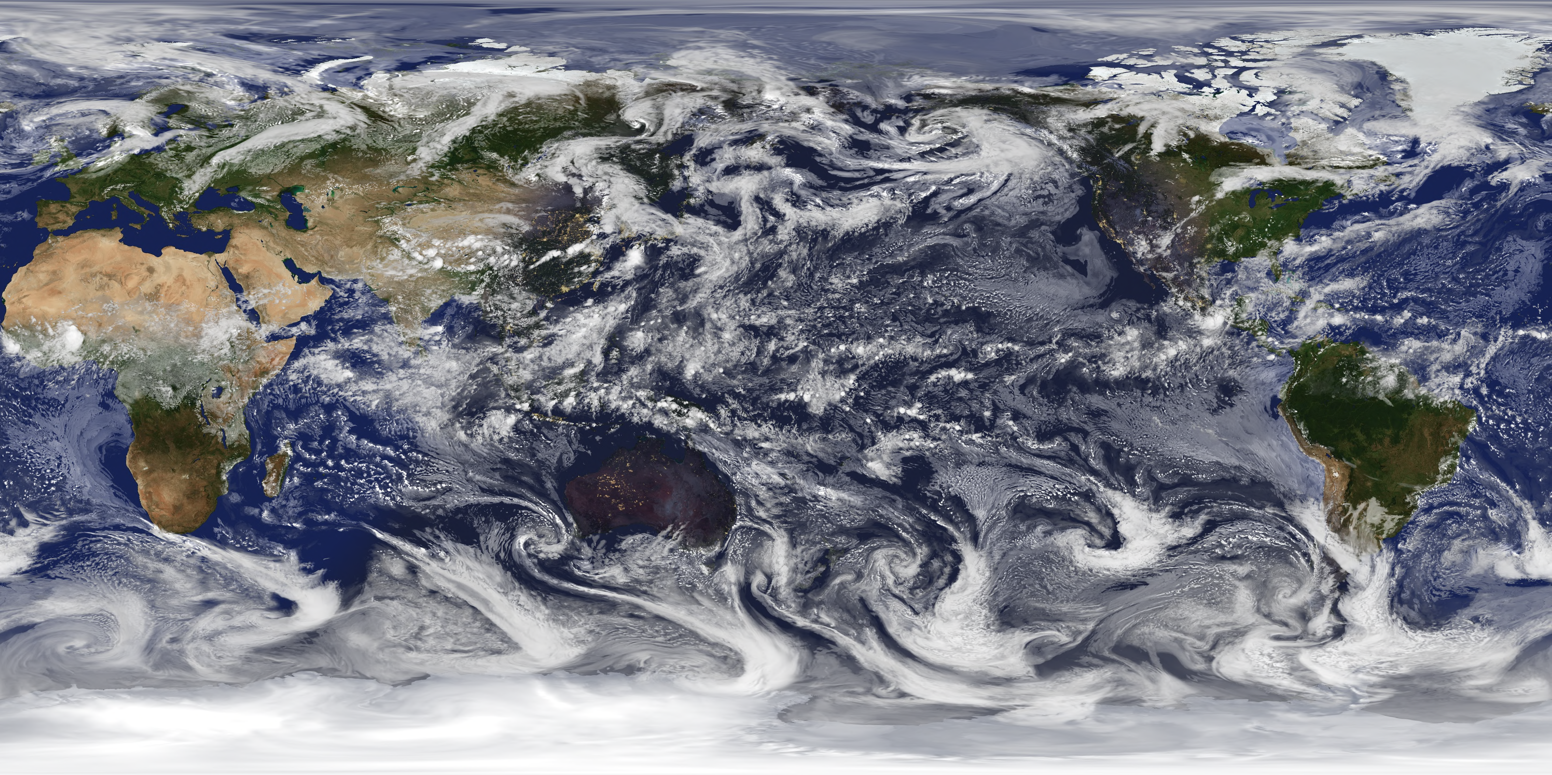
The GEOS-5 climate model being developed at NASA/Goddard Space Flight Center includes the major earth system components such as atmosphere, ocean biochemistry, land, aerosols, and combined tropospheric/stratospheric chemistry. For this proposal we will focus on the non-hydrostatic version of the GEOS-5 Atmospheric GCM
Visible cloud optical depth from the 7-km GEOS-5 global meso-scale simulation on 12 UTC September 19, 2005.
, radiatively coupled with GOCART aerosols and the NOBM ocean bio-chemical component running at 7-10 km global resolution. For several golden days in the period of 2 years (2005-2006) we will use the VLIDORT atmospheric radiative transfer (T) model coupled to the OASIM oceanic RT model to produce simulated water leaving and top-of-the atmosphere polarized reflectances as it would be observed by the PACE radiometer. These synthetic measurements will be used to explore several atmospheric correction strategies, quantify uncertainties, and establish the applicability limit of existing algorithms. While these simulated reflectances could be used for exploring the benefits of polarimetry and the retrieval of inherent optical properties of the ocean, these activities are beyond the scope of this proposal. However, it is our intention to make this simulation capability a resource available to other members of the PACE Science Team engaging in such activities.
The work being proposed directly address element A.25 (PACE Science Team) of the ROSES 2013 call. In particular, it provides simulation capabilities to aid in the formulation of the PACE mission, enabling theoretical and analytical studies of the inherent optical properties of the oceans and atmospheric correction of ocean color radiometry. By providing a combination of physically realistic Level 2 atmospheric and ocean parameters (meteorology, clouds, aerosols, and ocean bio-chemical state), combined with detailed Level 1 observables (water living and to-of-atmosphere reflectances), this proposal provides a rigorous framework for algorithm development, validation and error characterization.

Scientific / Technical / Management

1 Technical Approach and Methodology

Objectives and Expected Significance

Main Objectives of This Proposal
Arlindo

Relevance to NASA Program Elements
Arlindo

1.2 Implementation: Building on Existing Capabilities
A nice introductory paragraph is in order.

1.2.1 GEOS-5 Earth Modeling System: Overview
Arlindo: cut and paste

1.2.2 Aerosols in GEOS-5
Arlindo: cut and paste

1.2.3 The NOBM Ocean Bio-geochemical Component
Watson: take a page or so with a nice figure.
Three-Dimensional Global Ocean Model: NASA Ocean Biogeochemical Model (NOBM)
A schematic of NOBM, a coupled ocean general circulation/biogeochemical/radiative model, illustrates the complex interactions among the three major components (Figure 2). The Ocean General Circulation Model (MOM5) is global 50 vertical levels.
The biogeochemical model utilizes the circulation fields and the vertical mixing processes to produce horizontal and vertical distributions of constituents. The biological constituents are non-conservative and have their own local dynamical processes. The model contains 4 phytoplankton groups (diatoms, chlorophytes, cyanobacteria, and coccolithophores), which differ in maximum growth rates, sinking rates, nutrient requirements, and optical properties to help represent the extreme variety of physical and biological environments encountered in a global model.
Four nutrients are included. Nitrogen limitation involves "new" use represented by nitrate and “regenerated” use represented by ammonium. Silicate is also included to regulate diatom growth, and iron as an important micro-nutrient in some oceanographic basins. Surface iron fluxes are derived from the soil dust model of Ginoux et al. (2001). Phytoplankton are ingested by a self-adapting herbivore component, which also contributes to the ammonium field through excretion. Three detrital components provide for storage of organic material, sinking, and eventual remineralization back to usable nutrients. Dissolved organic and inorganic carbon (DOC and DIC), alkalinity, and particulate inorganic carbon (PIC) are included to represent the ocean carbon cycle. This results in 16 state variables in the fully coupled model.
NOBM has been extensively validated against in situ and satellite data (Gregg and Casey, 2007a). Nitrate, silicate, and dissolved iron surface distributions were statistically positively correlated with in situ data across major oceanographic basins (P<0.05). Global annual departures were +18.9% for nitrate (model high), +5.4% for silicate, and +45.0% for iron. DIC concentrations were also strongly correlated with observations, with a global difference of only 1.5% (model high). Total surface chlorophyll was positively correlated with satellite (except Aqua) and in situ data sets across major basins. Global annual departures were -8.0% with SeaWiFS (model low), +1.1% with Aqua, and -17.1% with in situ data. The lack of correlation across basins with Aqua derived from very high chlorophyll values in the North Indian Ocean, where absorbing aerosols are a problem and Aqua tends to saturate, leaving a small unrepresentative region of chlorophyll values that escape the masks.
NOBM basin-scale relative abundance distributions of diatoms, cyanobacteria, and coccolithophores were statistically positively correlated with in situ data (P<0.05). Global mean differences of all groups were within 20% of observations (Gregg and Casey, 2007a). Chlorophyte relative abundance distributions represented the maximum departure from observations, at -17.2%, and additionally exhibited no correlation with observations. This was the only group that did not exhibit significant correlation between model and observations.
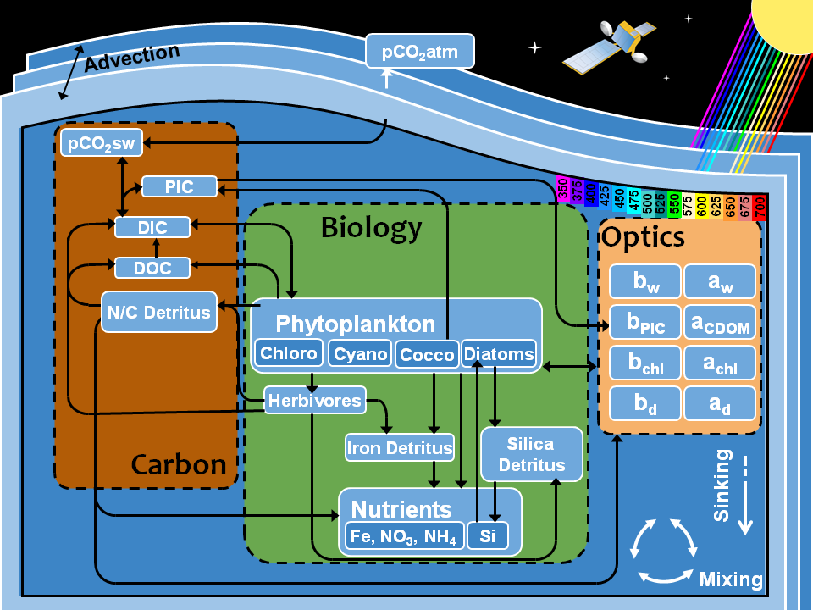

1.2.4 The GEOS-5 Global Mesoscale Simulation
Arlindo: basic configuration, period, resolution, emissions, etc. Perhaps in a table.

1.2.5 Radiative Transfer models: VLIDORT and OASIM
Arlindo: summarize VLIDORT main attributes
Watson: briefly describe OASIM

Radiative Transfer Model: Ocean-Atmosphere Spectral Irradiance Model (OASIM)
OASIM (Gregg and Casey, 2009) provides the underwater irradiance fields necessary to drive growth of the phytoplankton groups, and the resulting surface upwelling irradiance/radiance. The model contains a treatment of the spectral and directional properties of radiative transfer in the oceans, and explicitly accounts for clouds. It contains an optical characterization of atmospheric and in-water optical constituents.
The atmospheric radiative model is based on the Gregg and Carder (1990) clear sky spectral model, extended to the spectral regions 200 nm to 4 μm, which accounts for >99% of the total solar extraterrestrial irradiance. The spectral resolution is variable, depending upon the major atmospheric and oceanic absorbing sources. There are 33 spectral intervals in the model, including 25-nm resolution for the 350-700 nm range, i.e., Photosynthetically Available Radiation (PAR), which is the interval of most interest in this proposal.
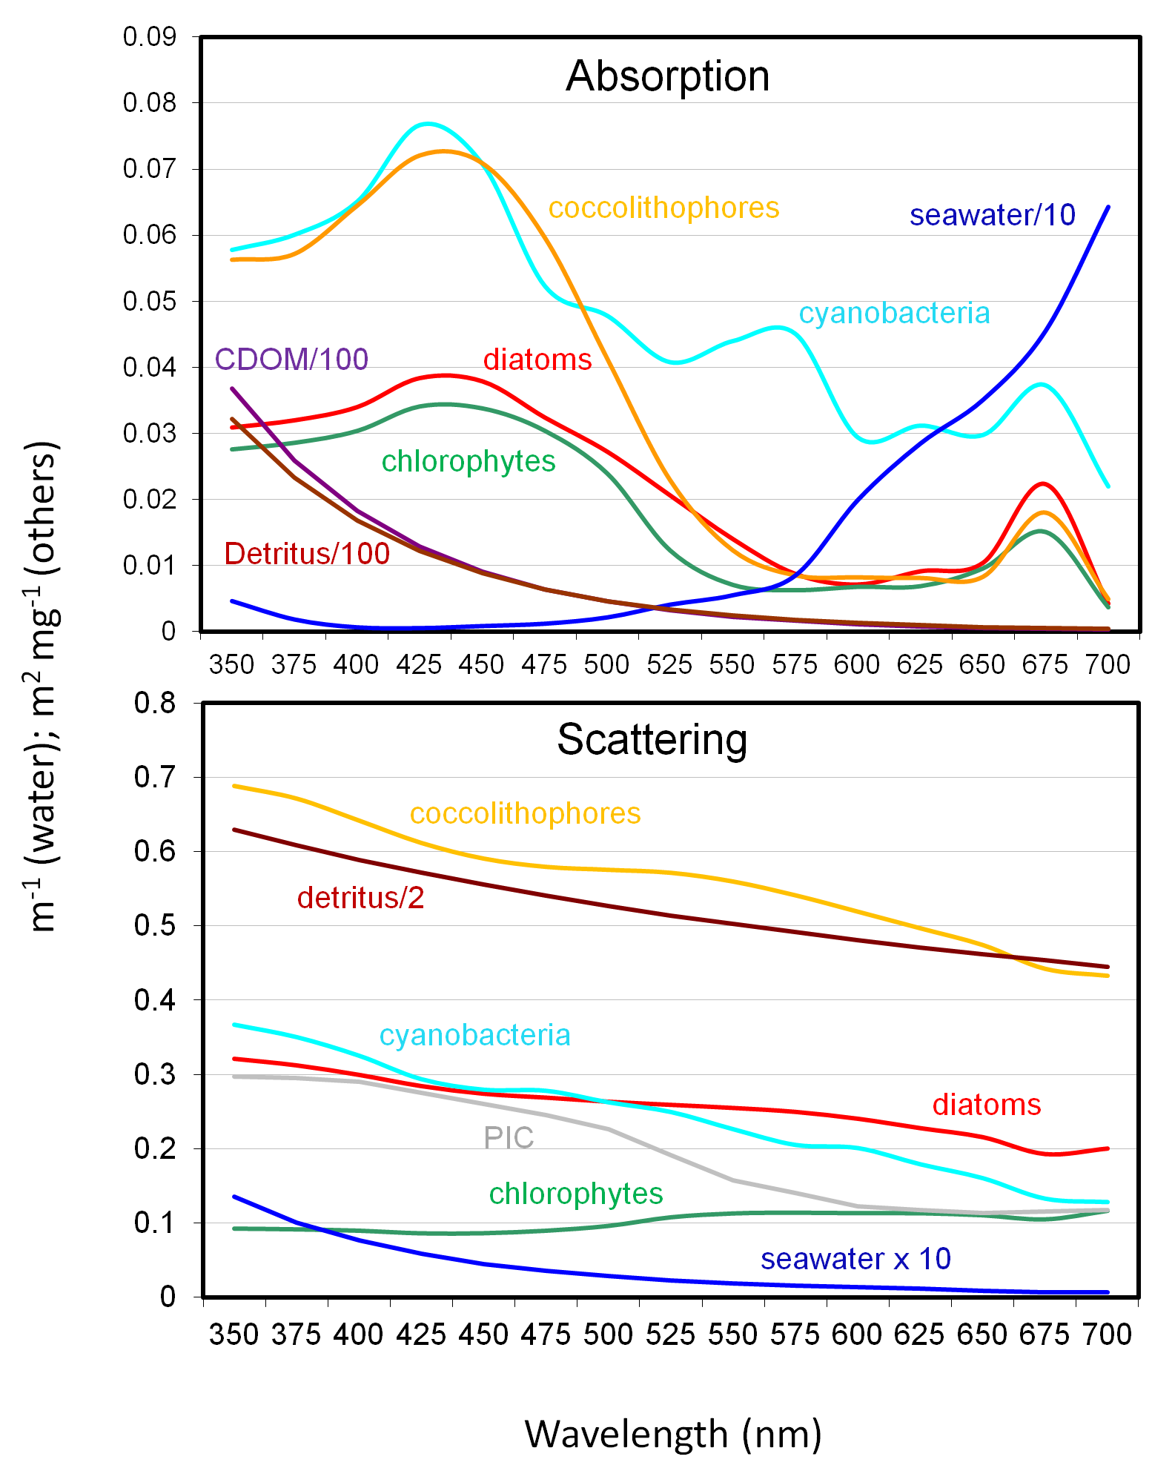
Figure 5. Spectral absorption and scattering coefficients of water
(m⁻¹), phytoplankton groups (m²mg⁻¹ chlorophyll), CDOM (m²mg⁻¹ CDOM), detritus (m²mg⁻¹C), and PIC (m²mg⁻¹CaCO₃) in OASIM.
The atmospheric portion of OASIM has been validated and published (Gregg and Casey, 2009). Spectrally-integrated surface irradiance from OASIM had root mean square (RMS) difference=20.1 Wm⁻² (about 11%), bias=1.6 W m⁻² (about 0.8%), regression slope=1.01 and correlation coefficient=0.89, when compared to 2322 in situ observations. Spectrally under clear skies the model has demonstrated a 6.6% RMS with in situ surface observations at 1 nm (Gregg and Carder, 1990).
Oceanic radiative properties are driven by water absorption and scattering, detrital absorption and scattering, CDOM absorption, and the optical properties of the phytoplankton groups (Figure 5). Three irradiance paths are enabled: a downwelling direct path, a downwelling diffuse (scattered) path, and an upwelling diffuse path. All oceanic radiative calculations include the spectral nature of the irradiance. Phytoplankton group-specific optical properties are derived from a variety of carefully controlled laboratory observations (Ahn et al., 1992; Bricaud et al., 1988; Bricaud et al., 1983; Morel, 1988; Morel and Bricaud, 1981; Sathyendranath et al., 1987). These characterizations are very similar to the compilation by Stramski et al. (2001) with different phytoplankton classification.
Ocean radiative transfer uses a “three-stream” method based on the Aas (1987) two stream approximation, modified for an explicit direct downwelling component by Ackleson et al. (1994). a_{CDOM} is represented as a diagnostic variable that varies with absorption by total chlorophyll (sum of the 4 phytoplankton components) using Morel and Maritorena (2001). This represents a deficiency in the model as currently configured because it does not allow a_{CDOM} to change independently of chlorophyll. Detritus is present in the model and contributes to irradiance absorption and scattering in OASIM. Specific detrital absorption and scattering coefficients are taken from Gallegos et al. (2011), as is the spectral slope of absorption, S_{d}(λ). Spectral scattering of PIC has recently been introduced into OASIM/NOBM, as indicated in Figure 5.

1.2.6 GEOS-5 OSSE Capabilities
Arlindo: very briefly summarize Errico’s effort, the MODIS cloud retrieval simulator and the OMI AI simulator.

1.2.7 The Nominal PACE Radiometer and Orbit
Ocean co-I: Summarize main characteristics from SDT report, including the bands and likely orbits. For the Level ½ simulators we will need for each orbit (or a smaller granule of it): longitude, latitude, viewing and solar geometry. It would be nice if we could say where we are going to get this information.
The proposed PACE mission is a hyrper-spectral imager intended to detect optically active constituents in the surface oceans. The nominal mission is 5nm spectral resolution for the range 350-750nm, encompassing the visible and parts of the UV and NIR where optically active substances have their greatest effect on light. Proposed aggregation of these 5nm bands will improve the signal-to-noise and produce uneven band intervals. Additional bands in the NIR and SWIR can potentially enable improve atmospheric corrections over previous and current ocean color missions.
We will reconfigure OASIM to the spectral bands and widths of the nominal PACE mission. Using a nearly full complement of ocean optically active constituents, we can compute normalized water leaving radiances globally at the aggregated PACE bands and also at 5nm at high spatial resolution . Normalized means that the radiances are corrected for viewing geometry (assumed to be straight vertical) at the ocean surface. This will produce the ocean surface boundary condition for the PACE atmospheric correction simulation system.
Atmospheric correction from a simulated PACE mission requires that the normalization of the normalized water leaving radiances be removed, i.e., the straight vertical orientation of the radiances must have a directional component. This requires a viewer, which in this case is the spacecraft carrying PACE. There are two ways to provide this viewing geometry needed to replicate the PACE mission to support atmospheric correction: 1) simulate the PACE orbit using an orbit model corresponding approximately to the prescribed PACE mission as described in the PACE report, or 2) use the SeaWiFS orbit, which is very nearly the ideal orbit recommended by the PACE Science Definition Team (noon polar orbit descending node, including a tilt capability).
The latter option is simpler, and we intend to begin with this. This approach involves mimicking the SeaWiFS observations contained the the Level-2 data, and estimating the viewing and solar angles associated with each pixel. We will be careful to use observations before the spacecraft began to drift, which is to say, pre-2007. Global aerosol distributions with angular characteristics will be placed between the directional water leaving radiances and the expected positions of the SeaWiFS locations, which are expected to resemble PACE.

1.2.8 Atmospheric Correction Retrieval Algorithm
Ocean co-I: give of an idea of the algorithms you guys gave in place and that will adapted for this study.

Research and Analysis Plan
Enter text: overview of the research and analysis plan.

Task 1: High Resolution Ocean Bio-chemical Simulation
Arlindo/Watson: Brief described the NOBM run as forced by the atmospheric NR

Task 2: Level 2 Simulator: Meteorology, Clouds, Aerosols and Ocean Characteristics
Arlindo: Describe met/cloud/aerosol/parameters, gases
Watson: Describe the tracers and normalized water leaving reflectances
Normalized water leaving radiances will be computed from the NOBM/OASIM model configuration globally, for multiple spectral bands, and at high spatial resolution. Although the nominal Level-2 radiance product is distributed publicly as remote sensing reflectances (just the normalized radiances divided by the mean extraterrestrial spectral irradiance), the important geophysical variable needed for atmospheric correction simulation is normalized water leaving radiances.

Task 3: Level 1 Simulator: Water Leaving and Top-of-atmosphere Reflectances
Arlindo: say a few words about gas correction, aerosol optical properties, sea-ice handling, etc.
Watson: a few words on the Level 1 water leaving radiances: what is involved to go from the level 2 water leaving reflectances to this Level 1.
Level-1 simulation of water leaving radiances involves using the normalized radiances discussed above and inserting a viewer, which for a first guess will be the SeaWiFS mission. This will be the ocean surface boundary condition for the PACE atmospheric correction simulator.
Arlindo: include a table summarizing the data products.

Task 4: Assessing Atmospheric Correction Strategies
Ocean co-I. This is a very important task.

2 Impact of Proposed Work
Arlindo:

3 Plan of Work

3.1 Key Milestones
Arlindo: Prepare notional Gantt chart.

3.2 Management Structure & Personnel Responsibility
The Principal Investigator Dr. Arlindo da Silva (NASA/GSFC Code 610.1) will manage all technical and administrative aspects of this proposal. He will also be responsible for the design of the simulation software, and for evaluation of the Level 1 and Level 2 simulated data products. Dr. da Silva leads the aerosol data assimilation effort at the Glonal Modeling and Assimilation Office (GMAO) and he has been involved with satellite data assimilation since he joined GSFC in 1994; he was the lead developer of the GEOS-4 data assimilation system. He will devote approximately 25% of his time to this project, with 15% of his time being leveraged from GMAO core funds. He will be assisted by a full-time junior programmer who will provide software development support in all phases of this project.
Co-Investigator Dr. Watson Gregg ….will develop the global ocean normalized water leaving radiances using a global ocean biogeochemical simulation coupled to a hyper-spectral radiative transfer simulator. He will provide the radiances to the PI who will be responsible for bundling the ocean surface radiance model with the aerosol simulation. He will provide assistance to the PI for realistic viewing and solar geometries by providing SeaWiFS Level 2 data. He will require 0.3FTE in the first two years and 0.4FTE in the last.
Co-I Gregg is also Co-I on another PACE proposal, which involves using the NOBM/OASIM model configuration to facilitate algorithm development for phytoplankton group identification. The waork effeort is nearly the same for both efforts. In the event that both proposal are selected for funding, Co-I Gregg will only ask for funding for one of the tasks (i.e., a total of 0.3, 0.3 and 0.4FTE for effort on both tasks).
Co-Investigator Dr. (Ocean Person) …
Collaborator …

3.3 Leveraging
Enter text

4 Data Sharing Plan
The datasets and software developed by this project will be made available to the scientific community at large as permitted by law and NASA regulations. The GEOS-5 Climate Modeling System has been made public under a NASA Open Source License and the improvements we plan to implement will be under the same licensing terms. The datasets produced by this project will be made available on-line via anonymous FTP as well as through OPeNDAP servers using mechanisms already in place at GMAO.

References

List of Acronyms

Biographical Sketches

Current and Pending Funding

Budget Justification: Narrative and Details
Enter Text

