Atmospheric Reanalyses
Recent Progress and Prospects for the Future
A Report from a Technical Workshop at
NASA GSFC, Greenbelt MD, April 2010

Introduction
Between early 2009 and early 2010, four new global atmospheric reanalyses became available for scientific research. These include ECMWF’s ERA-Interim reanalysis, NASA’s Modern Era Retrospective-analysis for Research and Applications (MERRA), NCEP’s Climate Forecast System Reanalysis (CFSR) and the CIRES Twentieth Century Reanalysis (20CR). In addition, the JMA has recently begun production of a new global reanalysis (JRA-55). With so much recent experience being focused on the methodologies and technologies of reanalyses, it seemed an opportune time to gather the primary developers for a meeting to review the system advances and lessons learned from the evaluations of the reanalyses. Thus, in April 2010, developers representing each of the major reanalysis centers met at Goddard Space Flight Center. The meeting agenda included overviews of each center’s development efforts, a discussion of the issues in observations, models and data assimilation, and, finally, identification of priorities for future directions and potential areas of collaboration. This white paper summarizes the deliberations and recommendations from the meeting.

Major System Advances
The earlier generations of reanalyses from NCEP and ECMWF have proven to be extremely valuable scientific tools, enabling climate and weather research not otherwise possible. They continue to be used, even with their known flaws, because the science community sees much of the basic utility available in each system: regular, gridded meteorological fields based on observations. The community of users has a broad array of needs, but those needs seem to be well met by time series of such gridded fields that is of long duration and that is kept current.
Individual centers have had their own objectives, depending on their mission (see Appendix A), in preparing these newest reanalyses. However, the primary rationale would seem to be the availability of new systems or updates to older systems that make some significant progress in addressing deficiencies in NCEP/NCAR R1 and ERA-40, especially in terms of the hydrological cycle and treatment of biases in satellite observations. Here we briefly summarize advances made in models, analysis/assimilation systems, and the treatment of observations.

Model
The models used in the latest reanalyses are not very different from those used, for example, for ERA-40 or NCEP R2. Of course there have been updates in the tuning of parameterizations as new satellite observations, especially from the EOS series, have provided new information and insight on cloud properties and moisture distributions. Perhaps the most significant development has been the implementation of prognostic cloud schemes, which have also facilitated updates to the use of moisture observations during assimilation. The inclusion of prognostic ozone has also allowed the assimilation of ozone retrievals and has a radiative impact. Otherwise, the higher horizontal and vertical resolution and extension of the vertical domain have been important to better representation of transports.

Analysis and Assimilation
The analysis schemes used in the current generation of reanalyses have been improved in several ways compared with their first-generation predecessors. ERA-Interim and JRA-55 use four-dimensional variational (4D-Var) algorithms, which take explicit account of the time dimension in accounting for the impact of observations during the assimilation window. This involves not only computing the observation-minus-background state departures at the “correct” time of the observations, but also using the forecast model to propagate the influence of the observations through time in a dynamically consistent manner. This is likely to be of increased importance during the satellite era in which large numbers of observations are available on a near-continuous basis.
MERRA and CFSR use a 3D-Var algorithm based on the Grid-point Statistical Interpolation (GSI) scheme originally developed at NCEP, which also includes a number of advancements over 3D-Var algorithms used previously. In particular, the observation-minus-background departures are computed with increased temporal accuracy, and a dynamic constraint on noise is employed to improve the balance properties of the analysis solution. In MERRA, an incremental analysis update (IAU) procedure is also used in which the analysis correction is applied incrementally to the forecast model through an additional tendency term in the model equations. This has ameliorated the spin-up problem with precipitation during the very early stages of the forecast and greatly improved aspects of the stratospheric circulation.
The 20CR is unique in its use of an ensemble Kalman filter (EnKF) to reanalyze observations of surface pressure from the late 1800’s to the present time. A well-known advantage of the EnKF is that the background error covariances evolve dynamically from one assimilation time to the next. The technique is especially well suited for problems involving a sparse observing network (in which accurate extrapolation of the available observational information to unobserved locations becomes critical), or an observing network that changes substantially during the course of the reanalysis (so that the background errors reflect the associated changes in the accuracy of the background forecast). Both aspects are of primary importance in 20CR.
Except for 20CR, the current reanalyses make extensive use of satellite radiance information, including data from hyper-spectral instruments such as AIRS and IASI. Successful use of these data requires careful quality control and bias correction procedures that are channel-specific. The bias in a given satellite channel can vary significantly in space and time depending on the atmospheric conditions, systematic errors in the radiative transfer model, and quality and age of the instrument. In most data assimilation schemes, the bias in each satellite radiance measurement is represented by a linear predictor model in which a relatively small number (~10) of parameters is used to describe these and other related dependencies. In the first-generation reanalyses that used satellite radiances, including ERA-40 and JMA-25, these parameters were estimated separately for each channel using an offline procedure based on a reference data set.
In the current reanalyses, bias estimation is performed automatically during the data assimilation procedure using a variational bias correction scheme. The bias parameters are updated each analysis cycle by including them in the control vector used to minimize the analysis cost function. This ensures that the bias estimates are continuously adjusted to maintain consistency of the bias-corrected radiances with all other information used in the analysis, including conventional observations and the model background state (Dee and Uppala 2009, henceforth DU09). An important technical advantage of this approach is that it removes the need for manual tuning and other interventions as the satellite observing system changes over time. The bias estimates also adapt in response to natural phenomena that can severely affect the radiance measurements, such as the Mt. Pinatubo eruption in 1991 (e.g., Figure 1, from DU09). The use of variational bias correction thus represents one of the most important advancements in the assimilation methodology of the current generation of reanalyses.
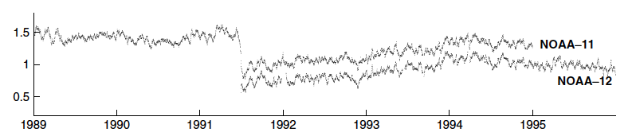
Figure 1: Tropical averages (20°S-20°N) of 12-hourly variational bias estimates (K) for HIRS channel 11 radiance data from NOAA-11 and NOAA-12 in ERA-Interim (from Dee and Uppala, 2009).

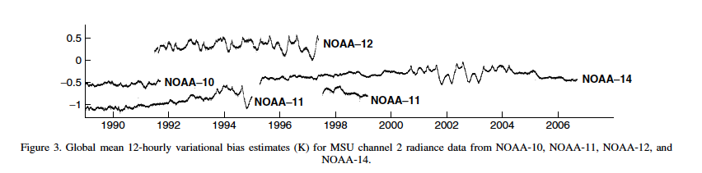
a
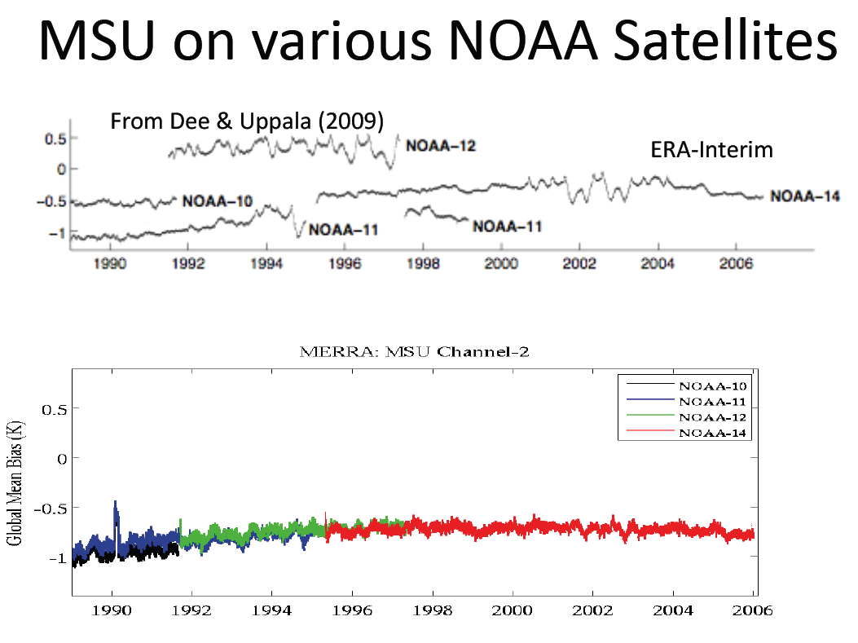
b
Figure 2: Global mean 12-hourly variational bias estimates (K) for MSU channel 2 radiance data from NOAA-10, NOAA-11, NOAA-12, and NOAA-14. The upper panel is from ERA-Interim (from Dee and Uppala, 2009) and the lower panel is from MERRA. The latter uses the cross-calibrated MSU data from NOAA/NESDIS.

Observations
Just as variational bias correction has provided significant benefit to the assimilation of satellite radiances, so have efforts (by data providers and others) to calibrate or reprocess certain observation data sets improved their usefulness in the current reanalyses. In terms of satellite observations, the Microwave Sounding Unit (MSU) on board NOAA-10, -11, -12 and -14 provides one of the longest records of remotely sensed atmospheric temperature from a single sensor type, extending from 1978—2007 with overlapping lifetimes of up to three years between satellites. In the original data sets, the global mean bias estimates for the same MSU channel on different satellites differ by up to a degree or more (Figure 2a), limiting the usefulness of these data for climate-change research and possibly having a negative effect in the variational bias correction scheme. The National Environmental Satellite, Data, and Information Service (NESDIS) has begun recalibrating observations from MSU and other instruments using a simultaneous nadir overpass (SNO, e.g., Zou et al., 2006) method. The recalibrated radiances for MSU channels 1—3 have been assimilated in MERRA, and exhibit near-uniform biases with a discernible upward trend over the length of the data record (Figure 2b).
Another important observational item worthy of mention is the treatment of radiosonde data since these data continue to have a major impact on global analyses. In addition to the radiation bias correction that all reanalyses applied to radiosonde temperatures to account for changing solar effects on the thermistor, MERRA and ERA-Interim applied some additional pre-processing corrections. Corrections for MERRA included the removal of large time-mean temperature differences in radiosonde observations collected at 00 and 12 UTC with the Vaisala RS-80 instrument. The differences occur as a result of a coding error in the post-processing software at the observing stations, and primarily affect observations in the stratosphere (Redder et al., 2004). The homogenization scheme of Haimberger (2007) was then applied to radiosonde observations (until 2005), with updated values consistent with the Vaisala RS-80 corrections described above. ERA-Interim also applied Haimberger’s homogenization correction, but using the correction developed without the prior correction of Vaisala RS-80 data. Finally, since those prior corrections were made for MERRA, the radiation bias correction applied to radiosonde temperature observations (until 2005) was modified so that it could still account for seasonal changes in the solar elevation angle that affect the thermistor even in the presence of those other corrections.

Quality of the Reanalyses
In this section, we provide an assessment of the extent to which these system advances have led to measureable improvements in the reanalysis products. We briefly look at several, mostly climate-oriented, metrics that can be used to evaluate the quality of the reanalyses. The view includes both improvements over the previous generation of analyses and remaining deficiencies. For the latter, we attempt to highlight the problems that are common to all the reanalyses, while for the former we highlight major improvements regardless of whether or not they occur in all the reanalyses. In that way we hope to avoid focusing on problems that are specific to any one system, while emphasizing the capabilities and promises that current reanalysis technologies can offer the climate community.
A basic question is how to measure the quality of reanalysis products. The current discussion is organized around four types of metrics: (1) the quality of forecasts made from the analyzed states, which itself requires appropriate metrics; (2) climate-related diagnostics with comparisons against observation-only based products; (3) the magnitude and nature of analysis increments, particularly systematic corrections that are required to keep the assimilation close to the observed trajectory and affect the energy and water budgets of the atmosphere; and (4) the sensitivity of the product to changes in the observing system, which is particularly important if the reanalyses are to be useful in assessing climate change.

Evaluations through weather forecast skill
The occasional repetition of the exercise of analyzing historical meteorological data has been driven by the steady improvements of the data assimilation systems used for operational weather predictions. Modern systems are capable of extracting much more information from earlier data than the systems that were operational at the time the observations were taken. This effect is dramatically illustrated in Figure 3 (from DU09), which shows how the forecast skill of the operational ECWMF system has improved over time (upper panel), as compared with the forecast skill when more recent ECMWF systems are used to re-analyze the historical observation (lower panel). Since both operational and reanalysis forecasts are based on practically identical observation streams, the difference between the two can be attributed almost solely to improvements in the data assimilation system – better models and better analysis techniques.
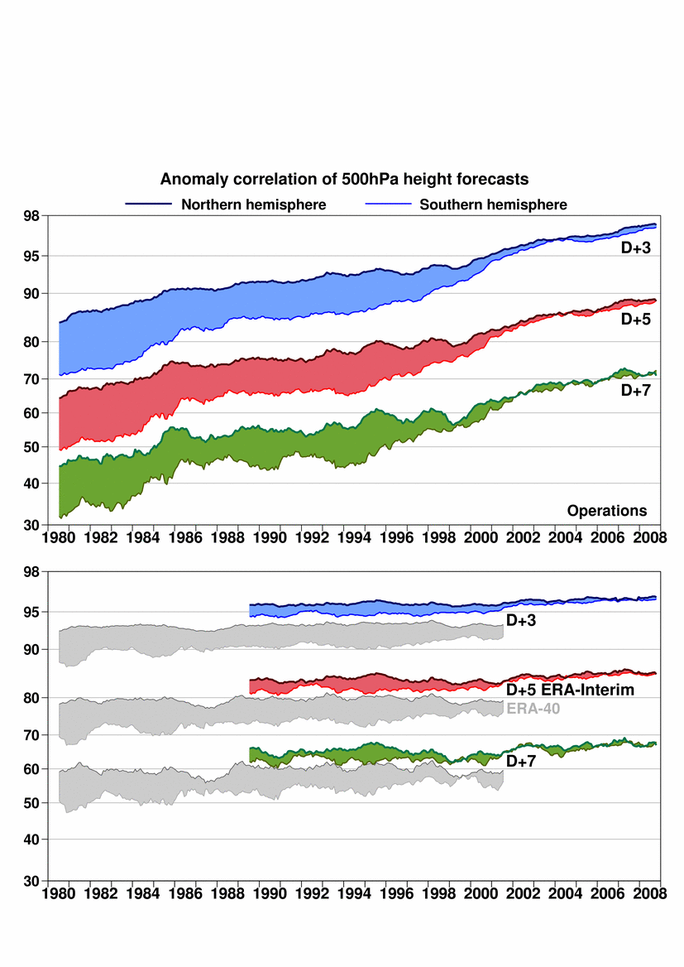
Figure 3: Extratropical anomaly correlations for 3-, 5-, and 7-day forecasts of 500 hPa height based on the ECMWF operational forecast system (top) and the ERA-Interim and ERA-40 reanalyses (bottom), after Dee and Uppala (2009).
Improving the accuracy of an analysis is a central concern of the numerical weather prediction community as a means of achieving improved forecast skill. In the case of climate reanalyses it can be debated whether improving accuracy (and therefore forecast skill) should receive priority over other improvements such as temporal consistency (see section 3.4). It is clear, however, that accuracy is nevertheless an important property of reanalyses, impacting the quality of the first guess fields, as well as the physical consistency of the products (in the sense of having smaller analysis increments – discussed further below). Figure 3 shows how the ERA-Interim product has benefitted from the recent improvements to the operational model and analysis system, showing essentially modern-day skill levels extending back to the late 1980s where they are substantially above the operational skill levels of that time. Such an improvement in fact highlights the benefits of reanalyzing earlier periods with a fixed modern-day data assimilation system (including improved observations) in the sense that it can improve the consistency of the reanalysis products in the face of a changing observing system.
Is there any additional information from the CFSR?

Climate-related Diagnostics

Water and Energy Cycles
Current models have improved considerably in the representation of the hydrological cycle and reanalyses have benefited from that, though there are still outstanding issues especially in the representation of precipitation and clouds. Figure 4 shows that the quality of the precipitation has improved substantially in the more recent reanalyses in terms of both bias and spatial structure. In fact, the time series of the spatial correlations in Figure 4 show improvements in the earlier years (compare MERRA and CFSR with ERA-40) that again highlight the benefits of reanalyzing historical observations with an improved data assimilation system. The spatial maps of the bias in the January mean precipitation from the various reanalyses as estimated with the observation-only Global Precipitation Climatology Project (GPCP, Figure 5a), and the summary Taylor plots (Figure 5b) show that much of the improvement has occurred over the tropical oceans.
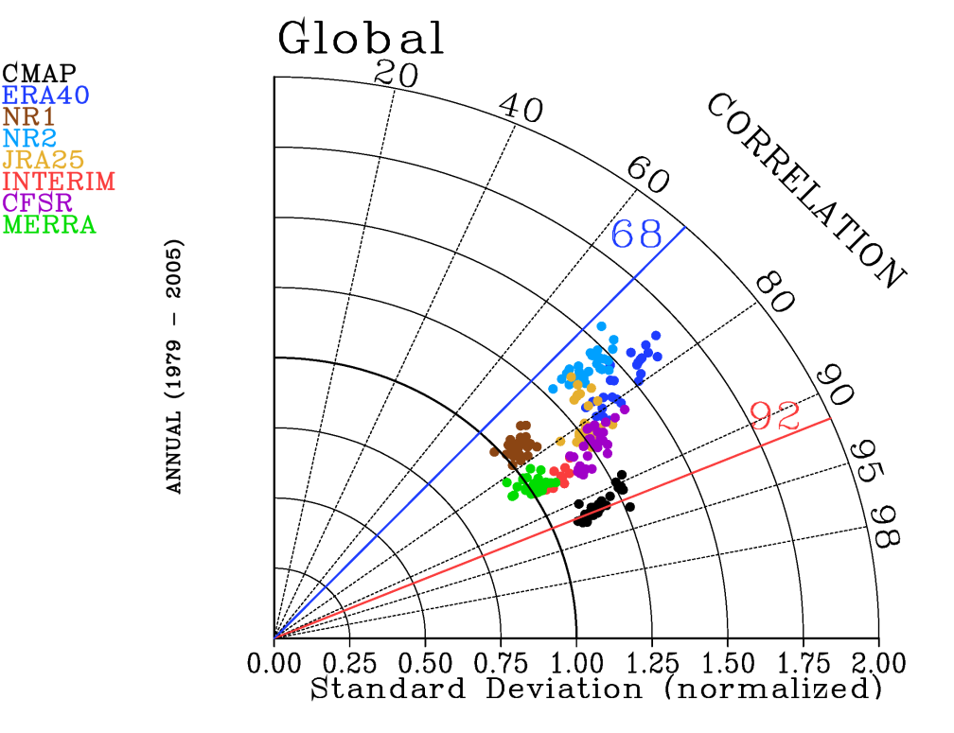
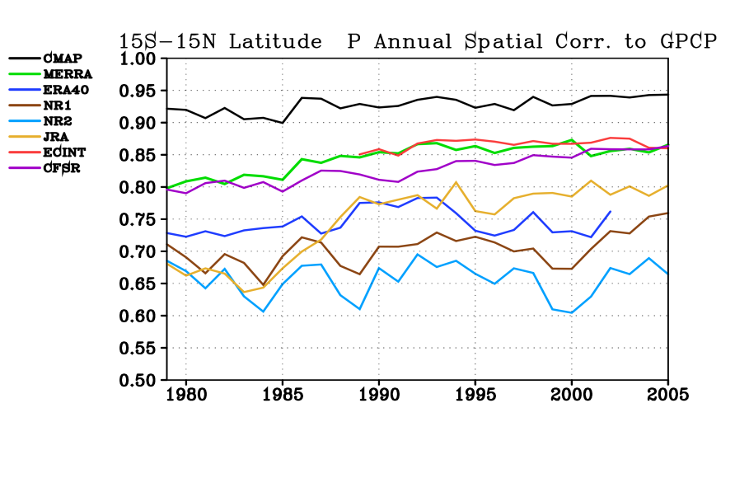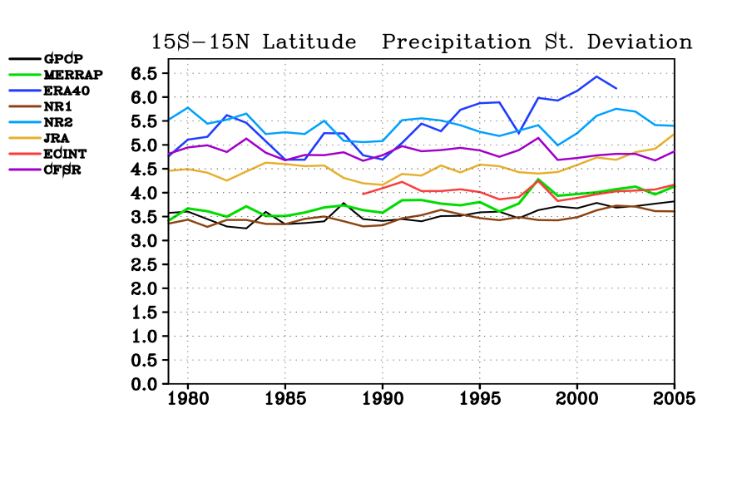
Figure 4: The time series of the spatial correlation of annual mean precipitation averaged over the tropics (15°S-15°N, left hand figure) from several reanalyses with that from GPCP and the average bias over the tropics (right hand figure). The comparison of CMAP against GPCP is also shown (black curves).
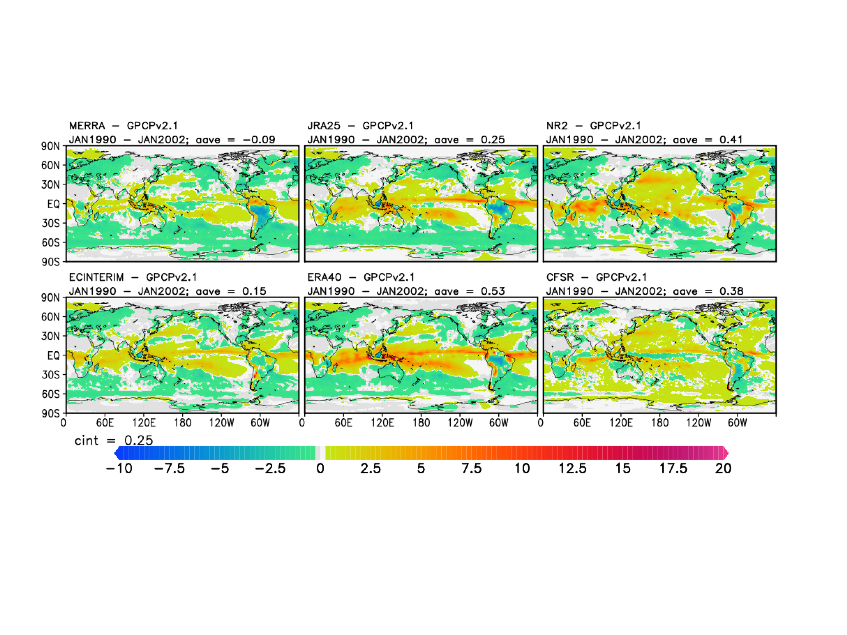
Figure 5a: The precipitation bias (mm/day) for January in several reanalyses relative to GPCP, for the period 1990-2002.
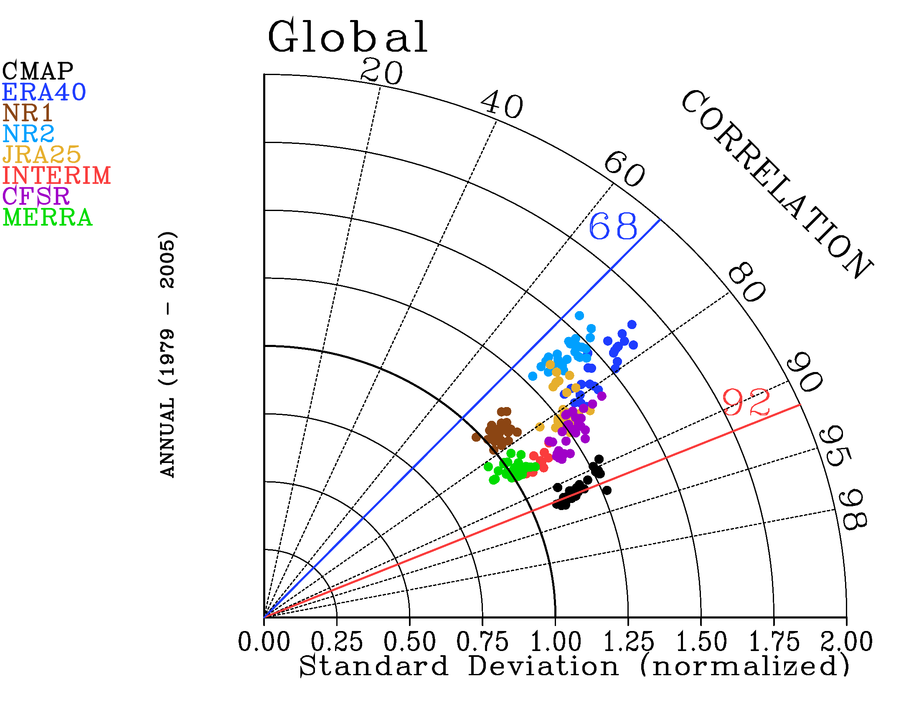
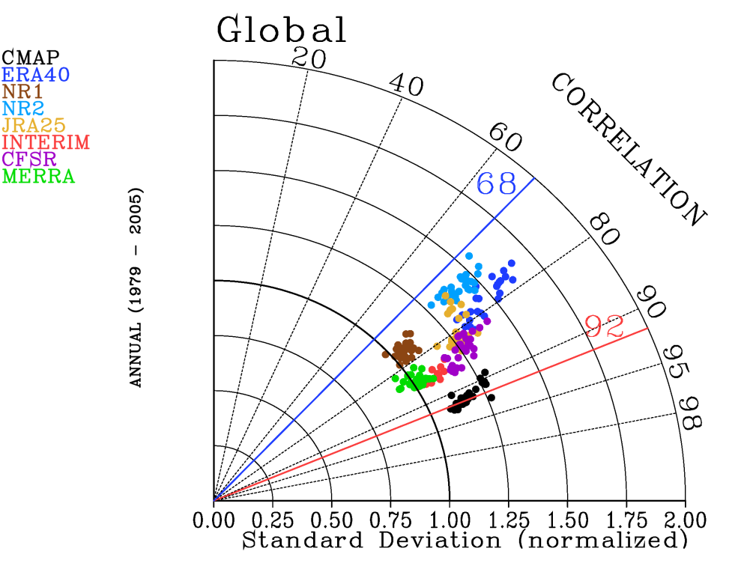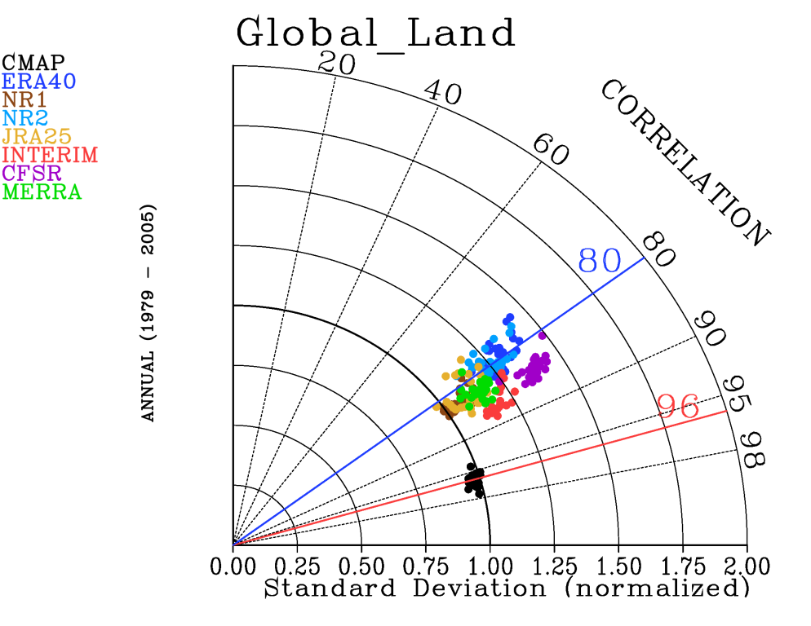
(c)
(a)
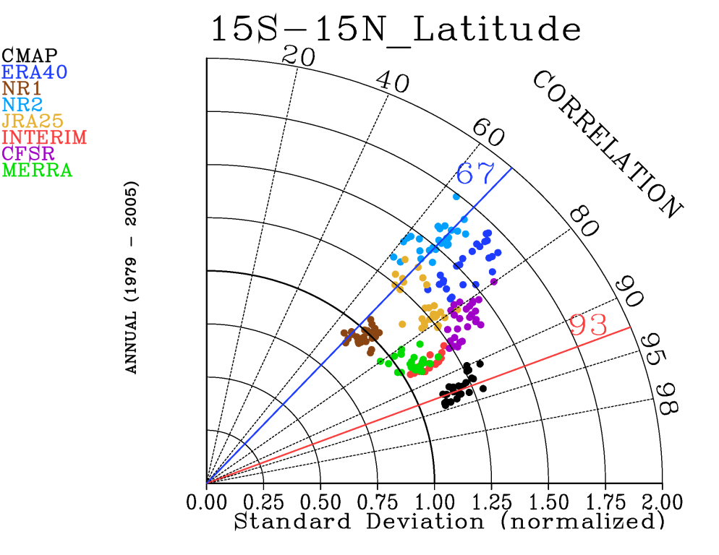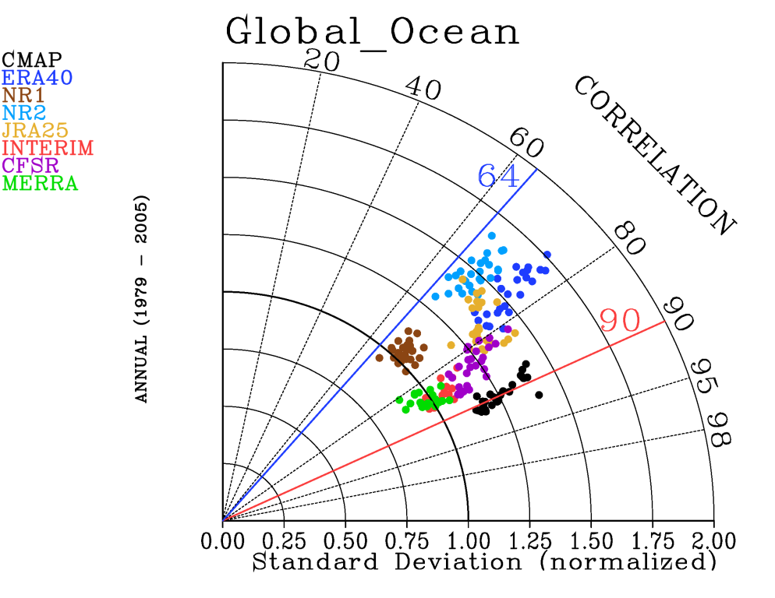
(d)
(b)
Figure 5b: Taylor diagrams of annual mean precipitation from reanalyses using GPCP as a reference and CMAP as an additional observing reference. Each panel shows the statistics for different regions: (a) globe, (b) tropics, (c) global land, and (c) global oceans. The red and blue lines show limits of expected high and low correlation as determined by comparing GPCP and CMAP observations. See Bosilovich et al. (2008) for details.

Earlier reanalyses were limited in their ability to support water and energy budget analyses, having large biases in the various physical forcing terms (e.g., precipitation, heating rates). “Forcing” fields could only be estimated as a residual of the terms that involved quantities that were strongly constrained by the analysis (e.g., rotational wind) and less dependent on the model physical parameterizations.
In conducting MERRA, emphasis was placed on providing a complete and internally consistent budget including any unphysical terms associated with the analysis increments and other non-physical adjustments (e.g., filtering). For example, Figure 6 shows the various terms in the vertically integrated moisture budget from MERRA, indicating that while the bias (e.g., in precipitation) has been reduced compared to previous reanalyses, the analysis increments nevertheless still contribute substantially to the budget.
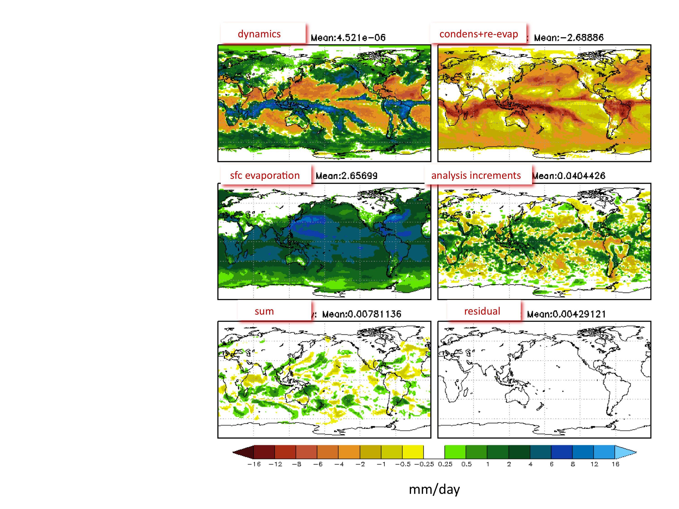
Figure 6: The vertically integrated water vapor budget from MERRA for January 2004.
Improvements in the representation of clouds remain a challenge affecting the quality of both the water and energy cycles. For example, cloud-related deficiencies are apparent in the joint frequency distribution of long-wave and short-wave fluxes at the top of the atmosphere shown in Figure 7. The joint frequency distribution of these fluxes may be viewed as a two-dimensional histogram that provides an evaluation of the processes that relate temperature, humidity and cloud fields. The latest reanalyses (MERRA and ERA-Interim) appear to have patterns closer to observed (CERES) than the earlier reanalyses (NCEP/DOE R2 and JRA-25), demonstrating the advances made in a general sense regarding the representation of the water and energy cycles.
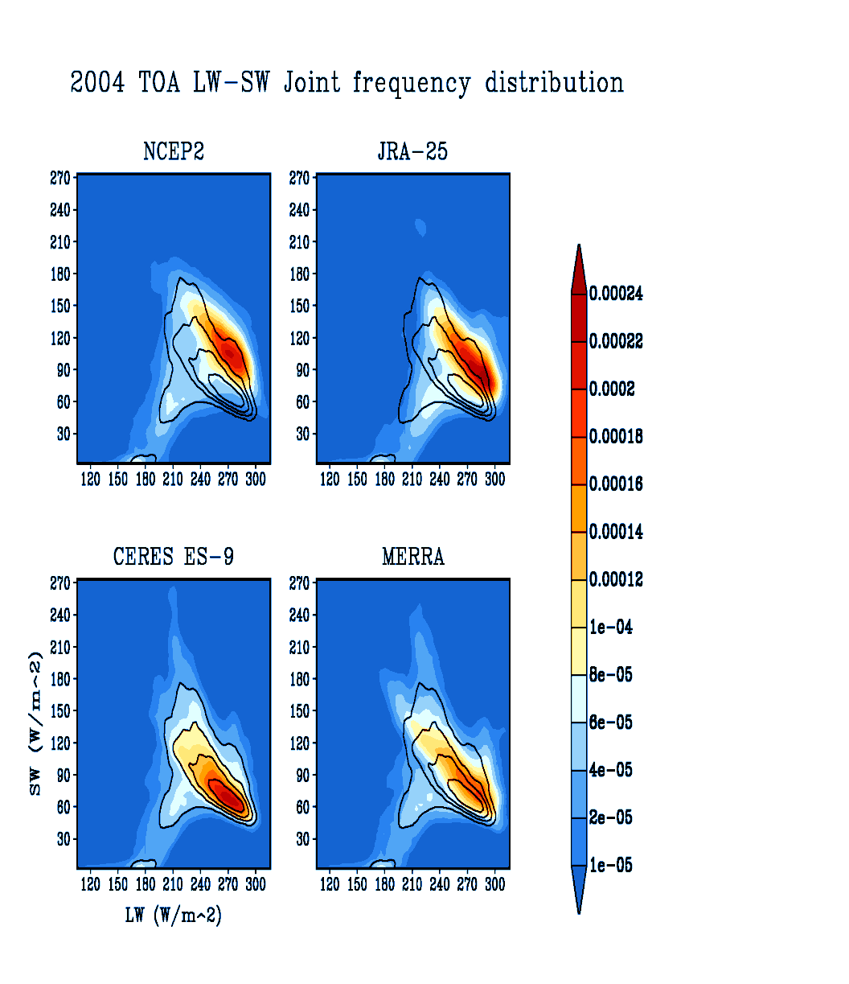
Figure 7: The joint frequency distribution of the top-of-atmosphere long-wave (abscissa) and short-wave (ordinate) fluxes for 2004 from MERRA, NCEP/DOE R2, and JRA-25. For comparison, the results are shown from CERES. The solid line contours from CERES overlay the shaded contours in all panels.
A summary of the annual and global mean energy flow and balances, estimated from recent reanalyses and compared with an observationally based estimate from Trenberth et al. (2009) is shown in Figure 8. Here, consistency and improvements appear to be greatest at the top of the atmosphere where the net fluxes from the recent reanalyses are all small, while substantial imbalances occur at the surface.
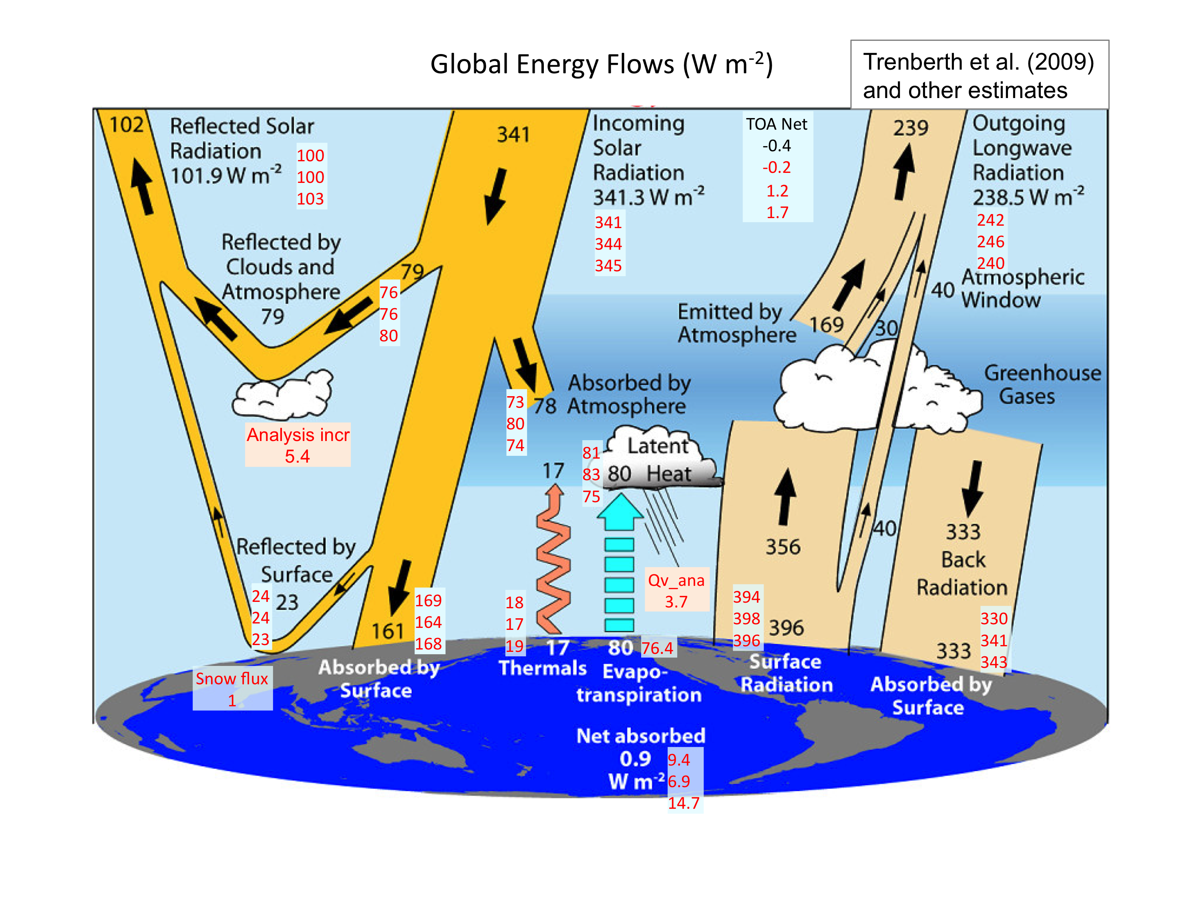
Figure 8: The global energy budget (W m⁻²) following Trenberth et al. (2009). The numbers in black are those from Trenberth et al.; the numbers in red are from MERRA, ERA-Interim, and from a satellite data climatology (REFERENCE???).

The lack of balance at the surface is one of the outstanding problems that continue to limit the use of reanalyses for driving ocean and land models. The primary causes of imbalances are related to the representation of clouds and also surface boundary layer parameterizations. Such deficiencies hinder efforts to develop coupled data assimilation systems.

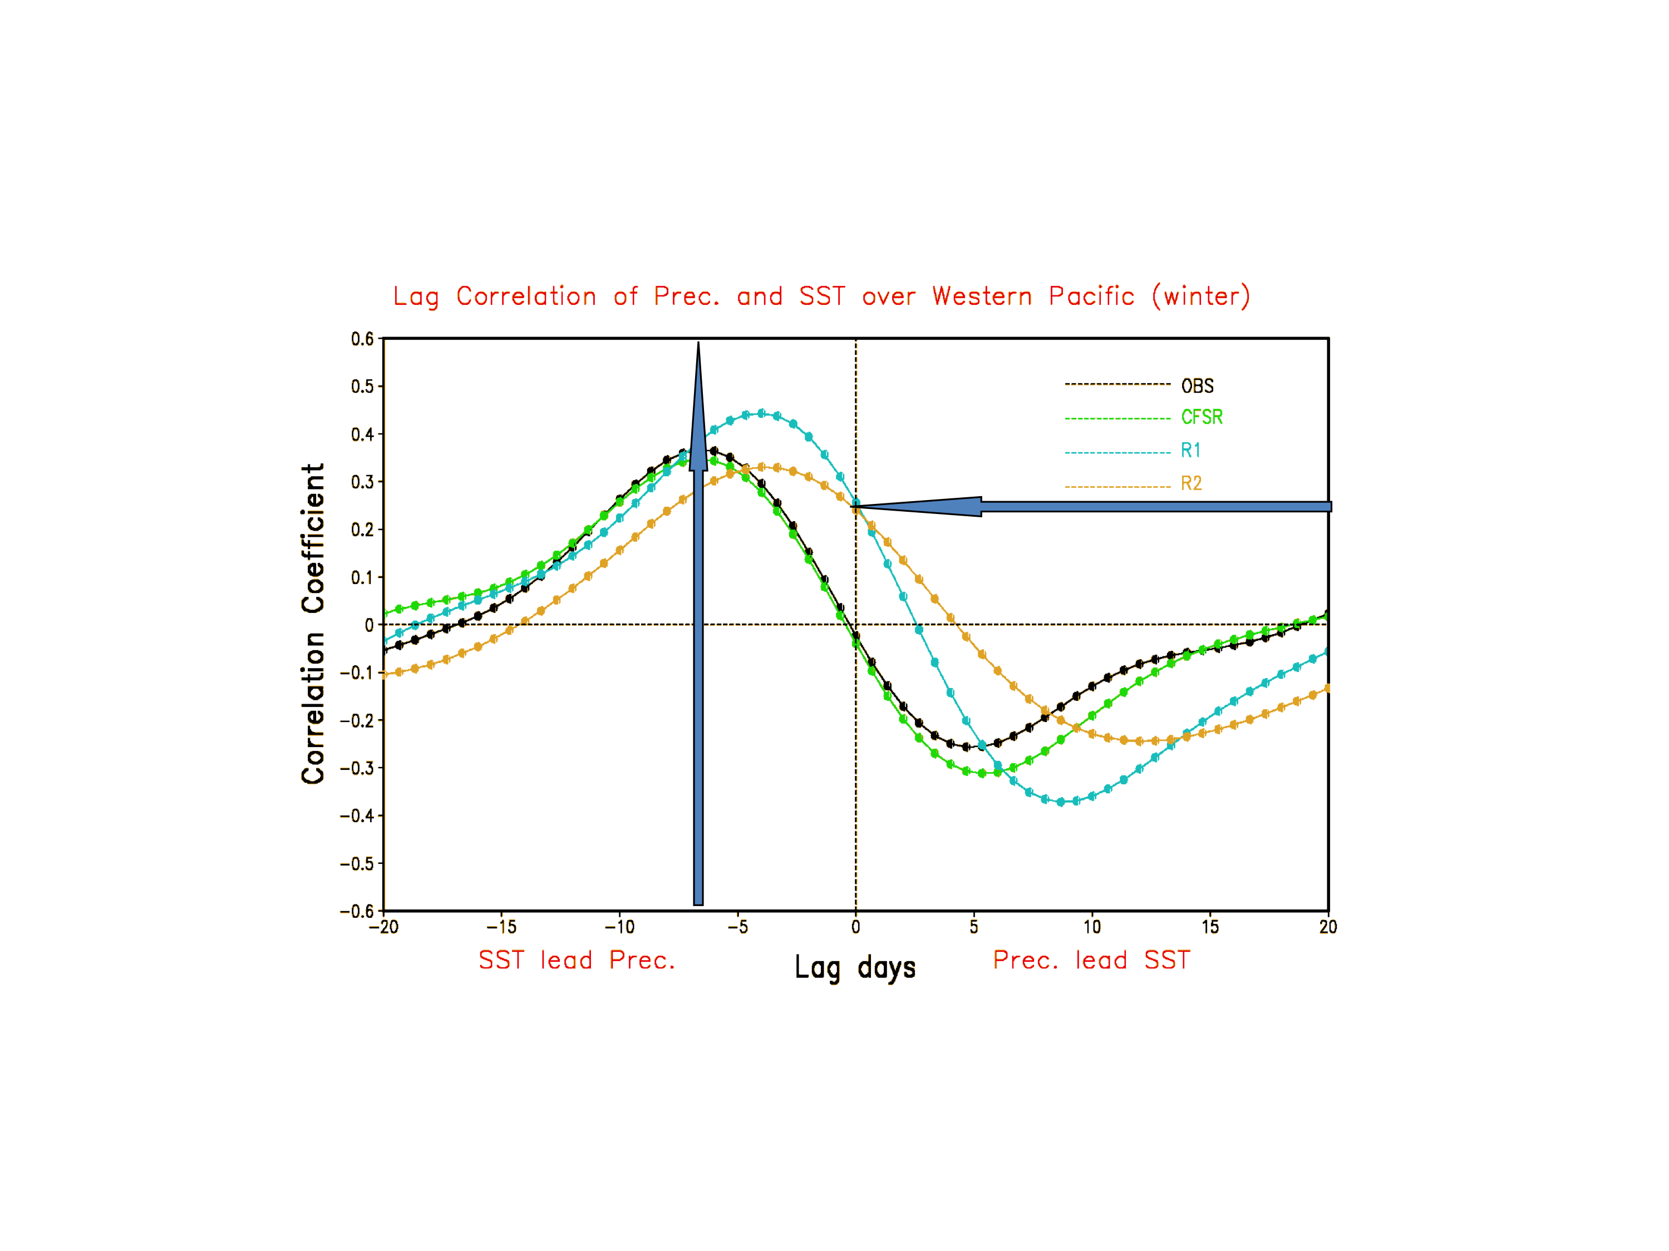
Figure 9: The lag correlation of precipitation and SST for winter over the Western Pacific. The correlation for CFSR is compared with that from observations, NCEP/NCAR R1, and NCEP/DOE R2. Positive lags denote precipitation is leading SST.
Ultimately, studies of water and energy cycle budgets and variability require consistent state estimates of the ocean and land surface. The use of specified SSTs impacts surface flux estimates and limits the consistency of the reanalyses in the surface boundary layer with state estimates elsewhere. Only the NCEP CSFR, by producing the analysis first guess with their coupled model, allows some degree of interaction between the atmosphere and ocean. One benefit of that is greater consistency between the SST and precipitation fields (e.g., Figure 9).

Interannual Variability
One of the strengths of the most recent reanalyses is in the representation of interannual variability, although the quality is not uniform, depending on both the variable of interest and the location (primarily vertical and latitudinal dependence). Figure 10 shows, for example, a very high degree of agreement between the MERRA and ERA-Interim climate anomalies (differences between two years) of the January 300 hPa eddy height field. This agreement is an improvement upon what was already a high level of agreement between ERA-Interim and the older ERA-40.
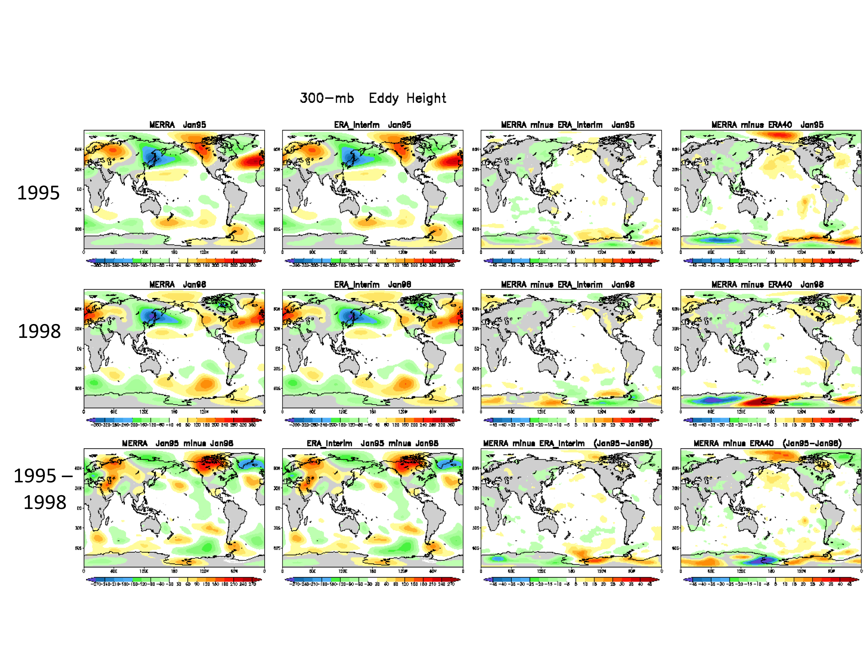
Figure 10: The eddy height field at 300 hPa for January 1995 (upper row) and January 1998 (middle row) from MERRA (first column) and ERA-Interim (second column). The differences between MERRA and ERA-Interim are shown in the third column while the fourth column compares MERRA with ERA-40. The bottom panels show the differences between the two years.
Figure 11 summarizes the correlations between selected MERRA January-monthly-mean quantities and other established observational estimates or, if the latter are unavailable, between MERRA and ERA-Interim. It is clear that the agreement between MERRA and ERA-Interim for the 300mb eddy height fields is, with the exception of some tropical regions, quite high everywhere (global mean of the local correlations is 0.98), consistent with the results shown in Figure 10. While there is also generally close agreement between the two reanalyses in the 850mb u-wind, it is significantly less than that for the 300mb eddy field. Some of the lowest correlations occur over tropical land and surrounding regions, including much of the tropical Atlantic. The high correlations between MERRA total precipitable water (TPW) and the SSM/I estimates over the ocean are not surprising since MERRA assimilated SSM/I radiances. On the other hand, the lower agreement with ERA-interim in the 850mb specific humidity reflects large uncertainties in the reanalyses regarding the vertical structure of the moisture field. This, in turn, reflects a lack of strong observational constraints combined with a general sensitivity of the vertical structure of the moisture to the model’s convection scheme.
The correlations drop further for quantities related to the divergent wind field (e.g., vertical velocity at 500mb) and the hydrological cycle (e.g., precipitation), although though one can find regions where the correlations are quite high, for example, over the tropical Pacific. It should be emphasized, however, that this overall level of agreement is a substantial improvement compared with previous reanalyses (see for example the Taylor plots in Figure 5b).
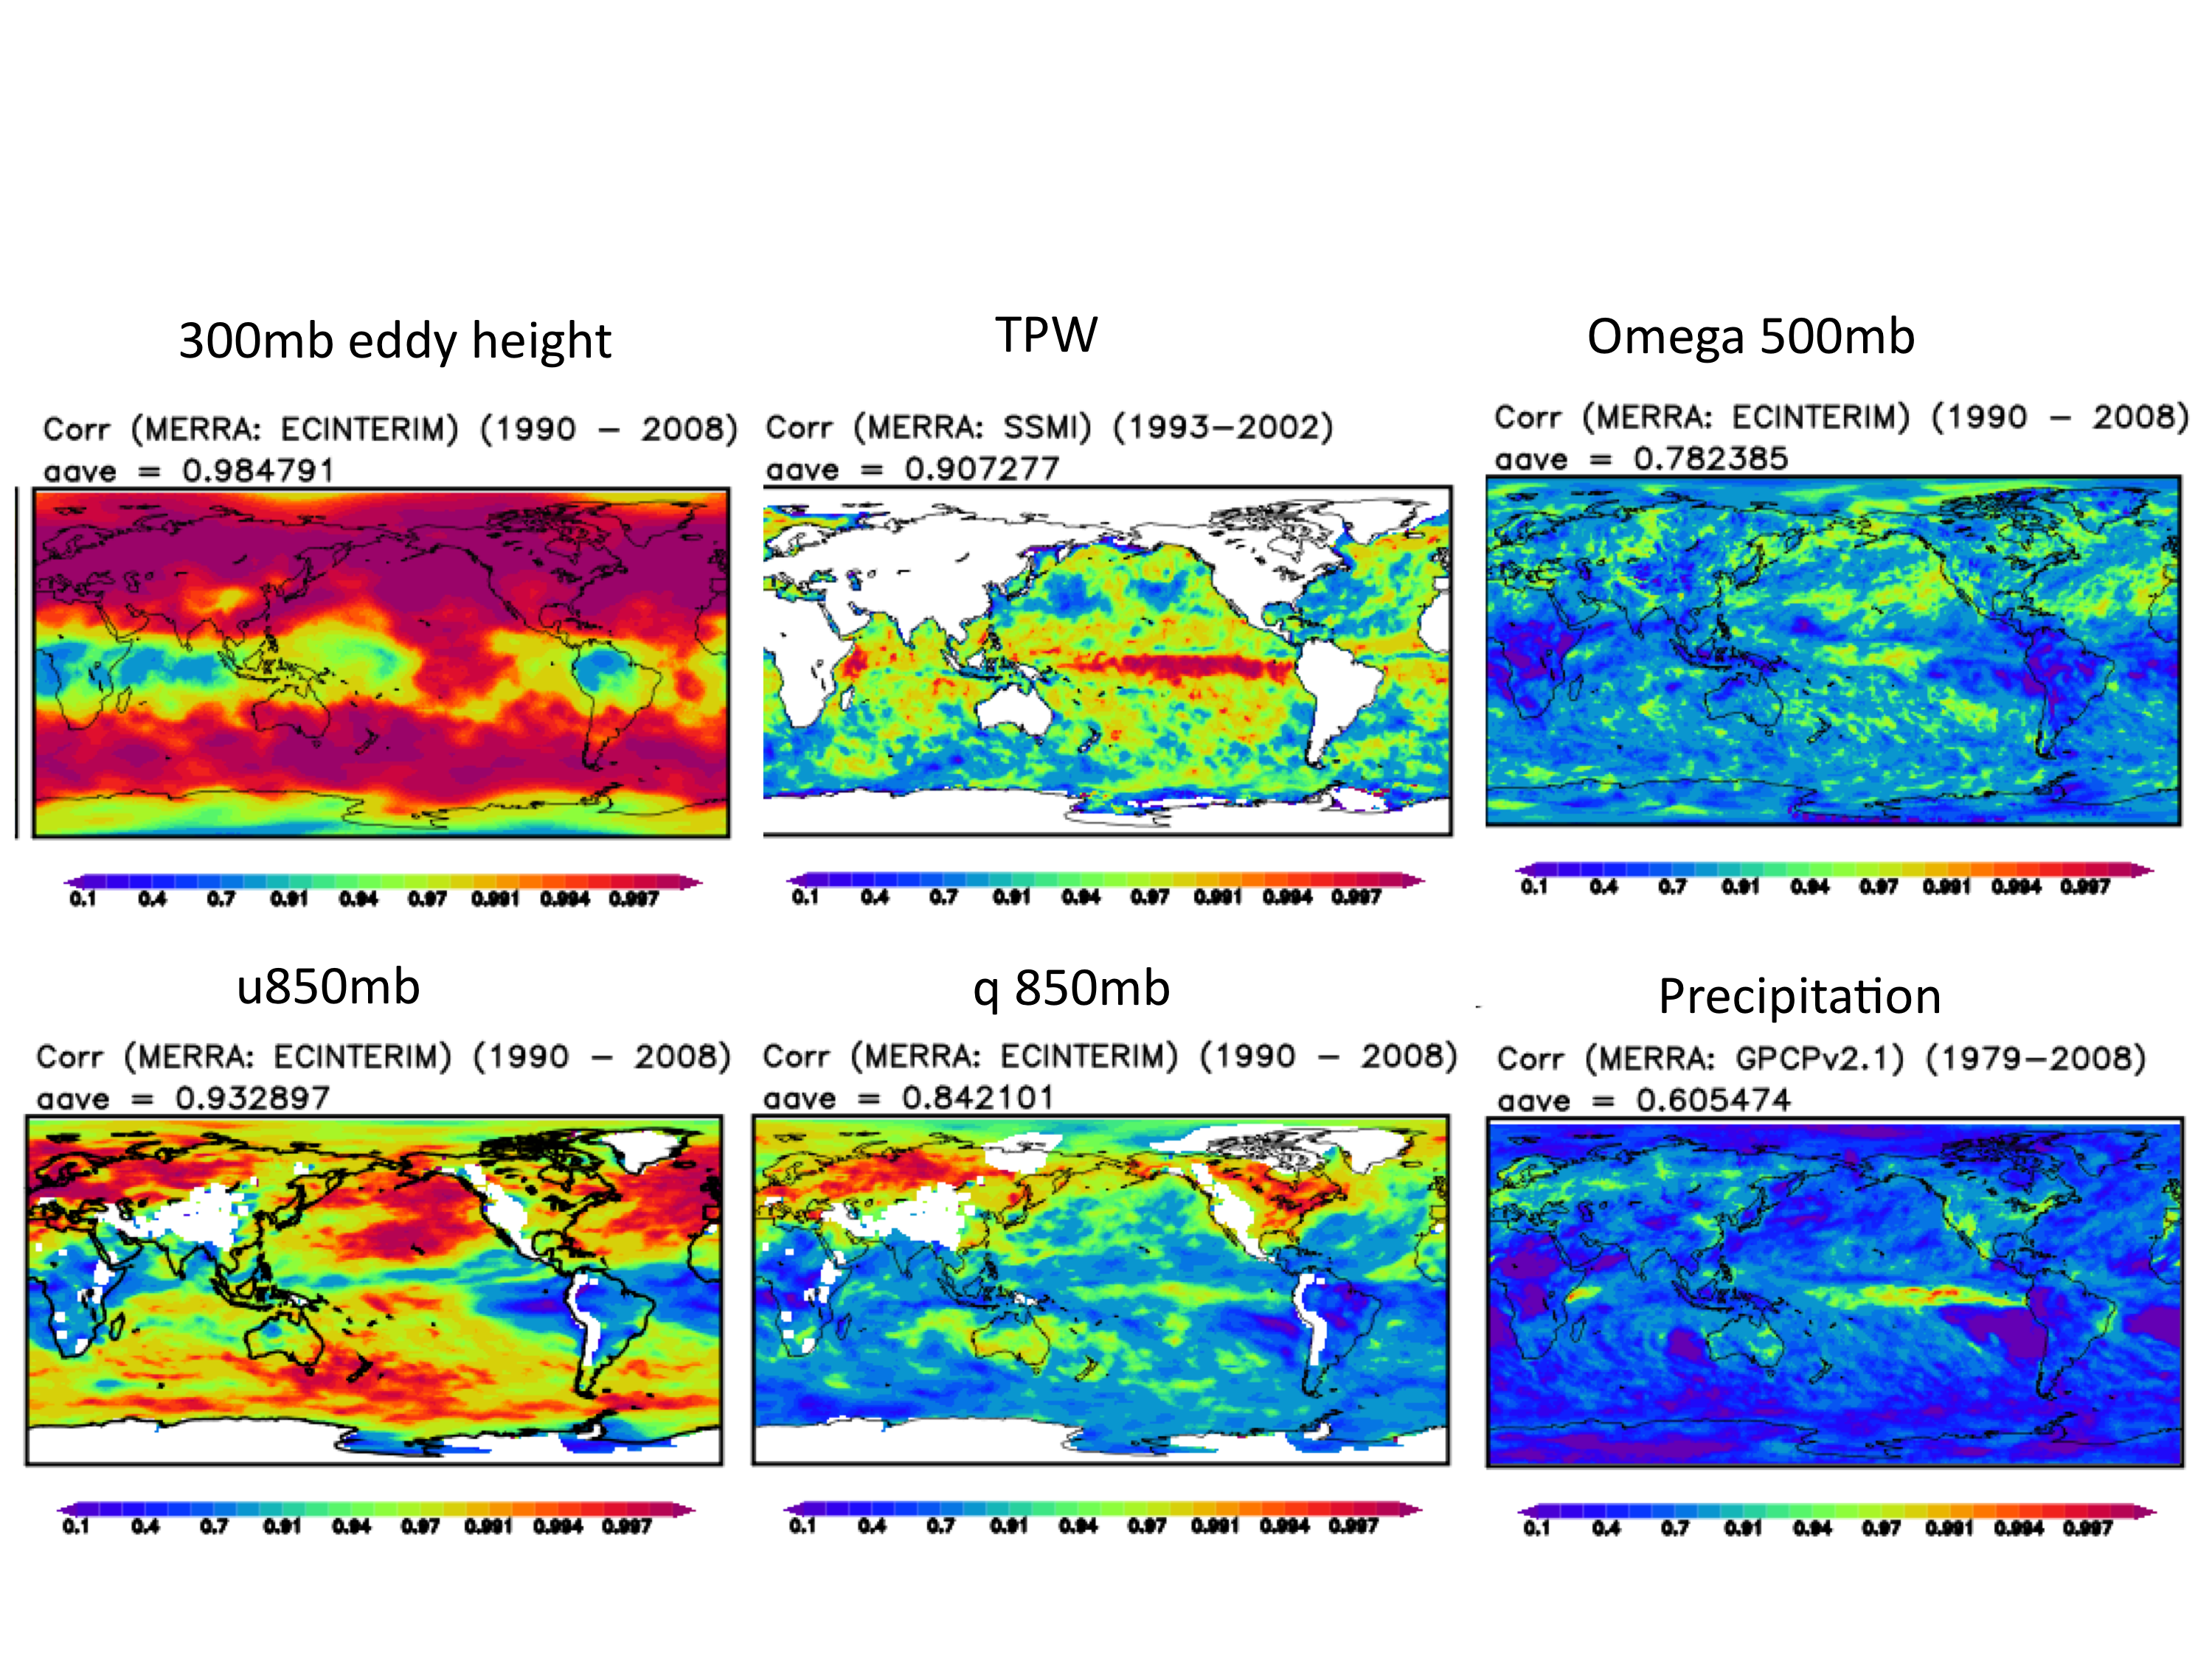
Figure 11: Correlations between MERRA and other field estimates for selected January-monthly-mean quantities. The comparisons with ERA-Interim (300 hPa eddy height, vertical velocity at 500 hPa, u-wind at 850 hPa and specific humidity at 850 hPa) are for 1990-2008. The comparison with SSM/I (TPW) is for 1993-2002, and the comparison with GPCPv2.1 (precipitation) is for 1979-2008.

Figure 12 summarizes results in terms of the zonal mean values of the correlation (R²) between MERRA and ERA-Interim, and between MERRA and selected observation data sets, for various quantities during January and July. The higher correlations for precipitation (and OLR) between MERRA and ERA-Interim, compared with the correlations between MERRA and GPCP, emphasize the fact that the reanalyses are still more like each other than they are like the observational estimates.
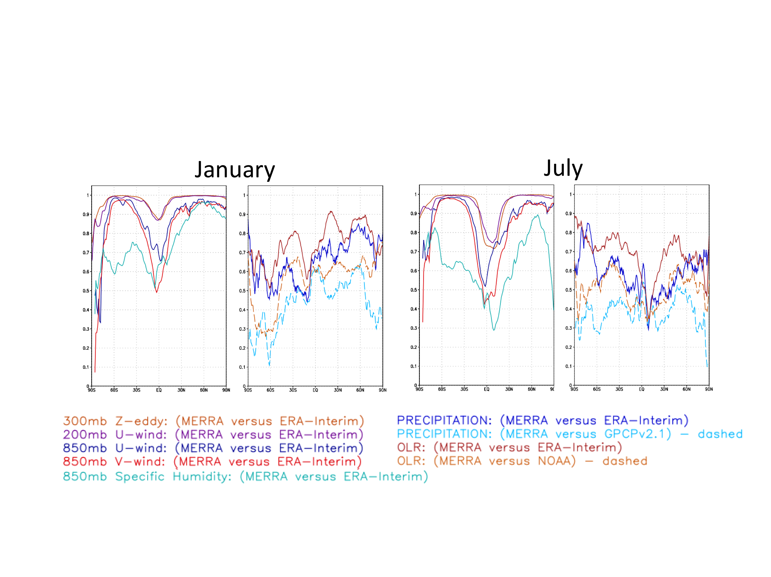
Figure 12: Zonal mean values of the correlation (R²) between MERRA and ERA-Interim, and between MERRA and selected observation data sets, for various quantities during January and July. The comparison with the NOAA observed OLR product is for the period1990 to 2008.

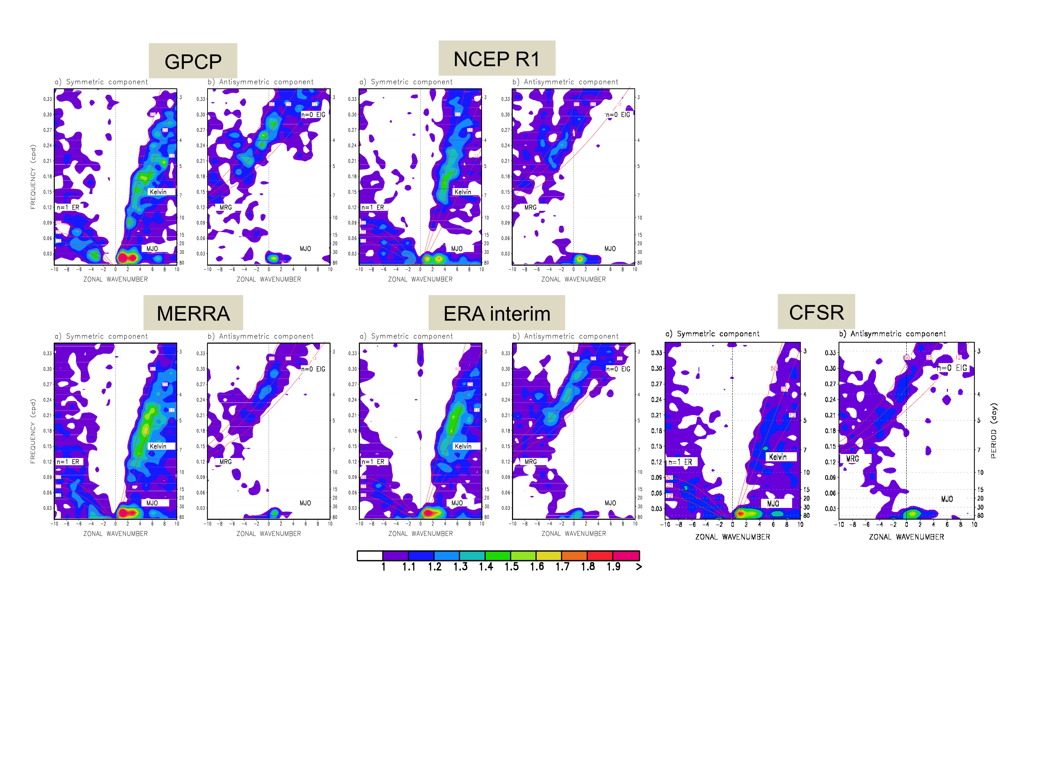
Figure 13: Wavenumber-frequency diagram for precipitation, following Wheeler and Kiladis (1999). ER is equatorial Rossby wave; EIG is eastward inertio-gravity wave, MRG is mixed Rossby-gravity wave. The calculations are based on daily precipitation for 1989-2008 averaged between 15°S and 15°N. For each product, the left-hand panel is the symmetric component and the right-hand panel is the anti-symmetric component.

Sub-seasonal Variability and the Diurnal Cycle
There have been significant improvements in the representation of intra-seasonal tropical variability, particularly in the representation of the MJO and other convectively coupled equatorial waves. For example, Figure 13 shows wavenumber-frequency diagrams (Wheeler and Kiladis 1999) for precipitation based on GPCP observations and several reanalyses. When compared against GPCP, the most recent reanalyses (MERRA, ERA-Interim and CSFR) show clear improvements over the earlier NCEP/NCAR R1 reanalysis in terms of the power associated with the MJO and the lower frequency Kelvin waves.
Reanalyses have traditionally provided good representations of synoptic-scale midlatitude weather systems (e.g., CCSP report). The recent reanalyses have considerably higher resolution than previous reanalyses and are beginning to provide useful information about the occurrence of tropical storms. For example, Figure 14 shows that tropical storm detection rates in CFSR are quite high for all but the eastern Pacific. In addition to enhanced resolution, this result likely also reflects the application of a tropical storm relocation procedure prior to performing the analysis. On the other hand, the most intense storms (for example, category 4 and 5 hurricanes) are still not well represented (see, e.g., Figure 15).

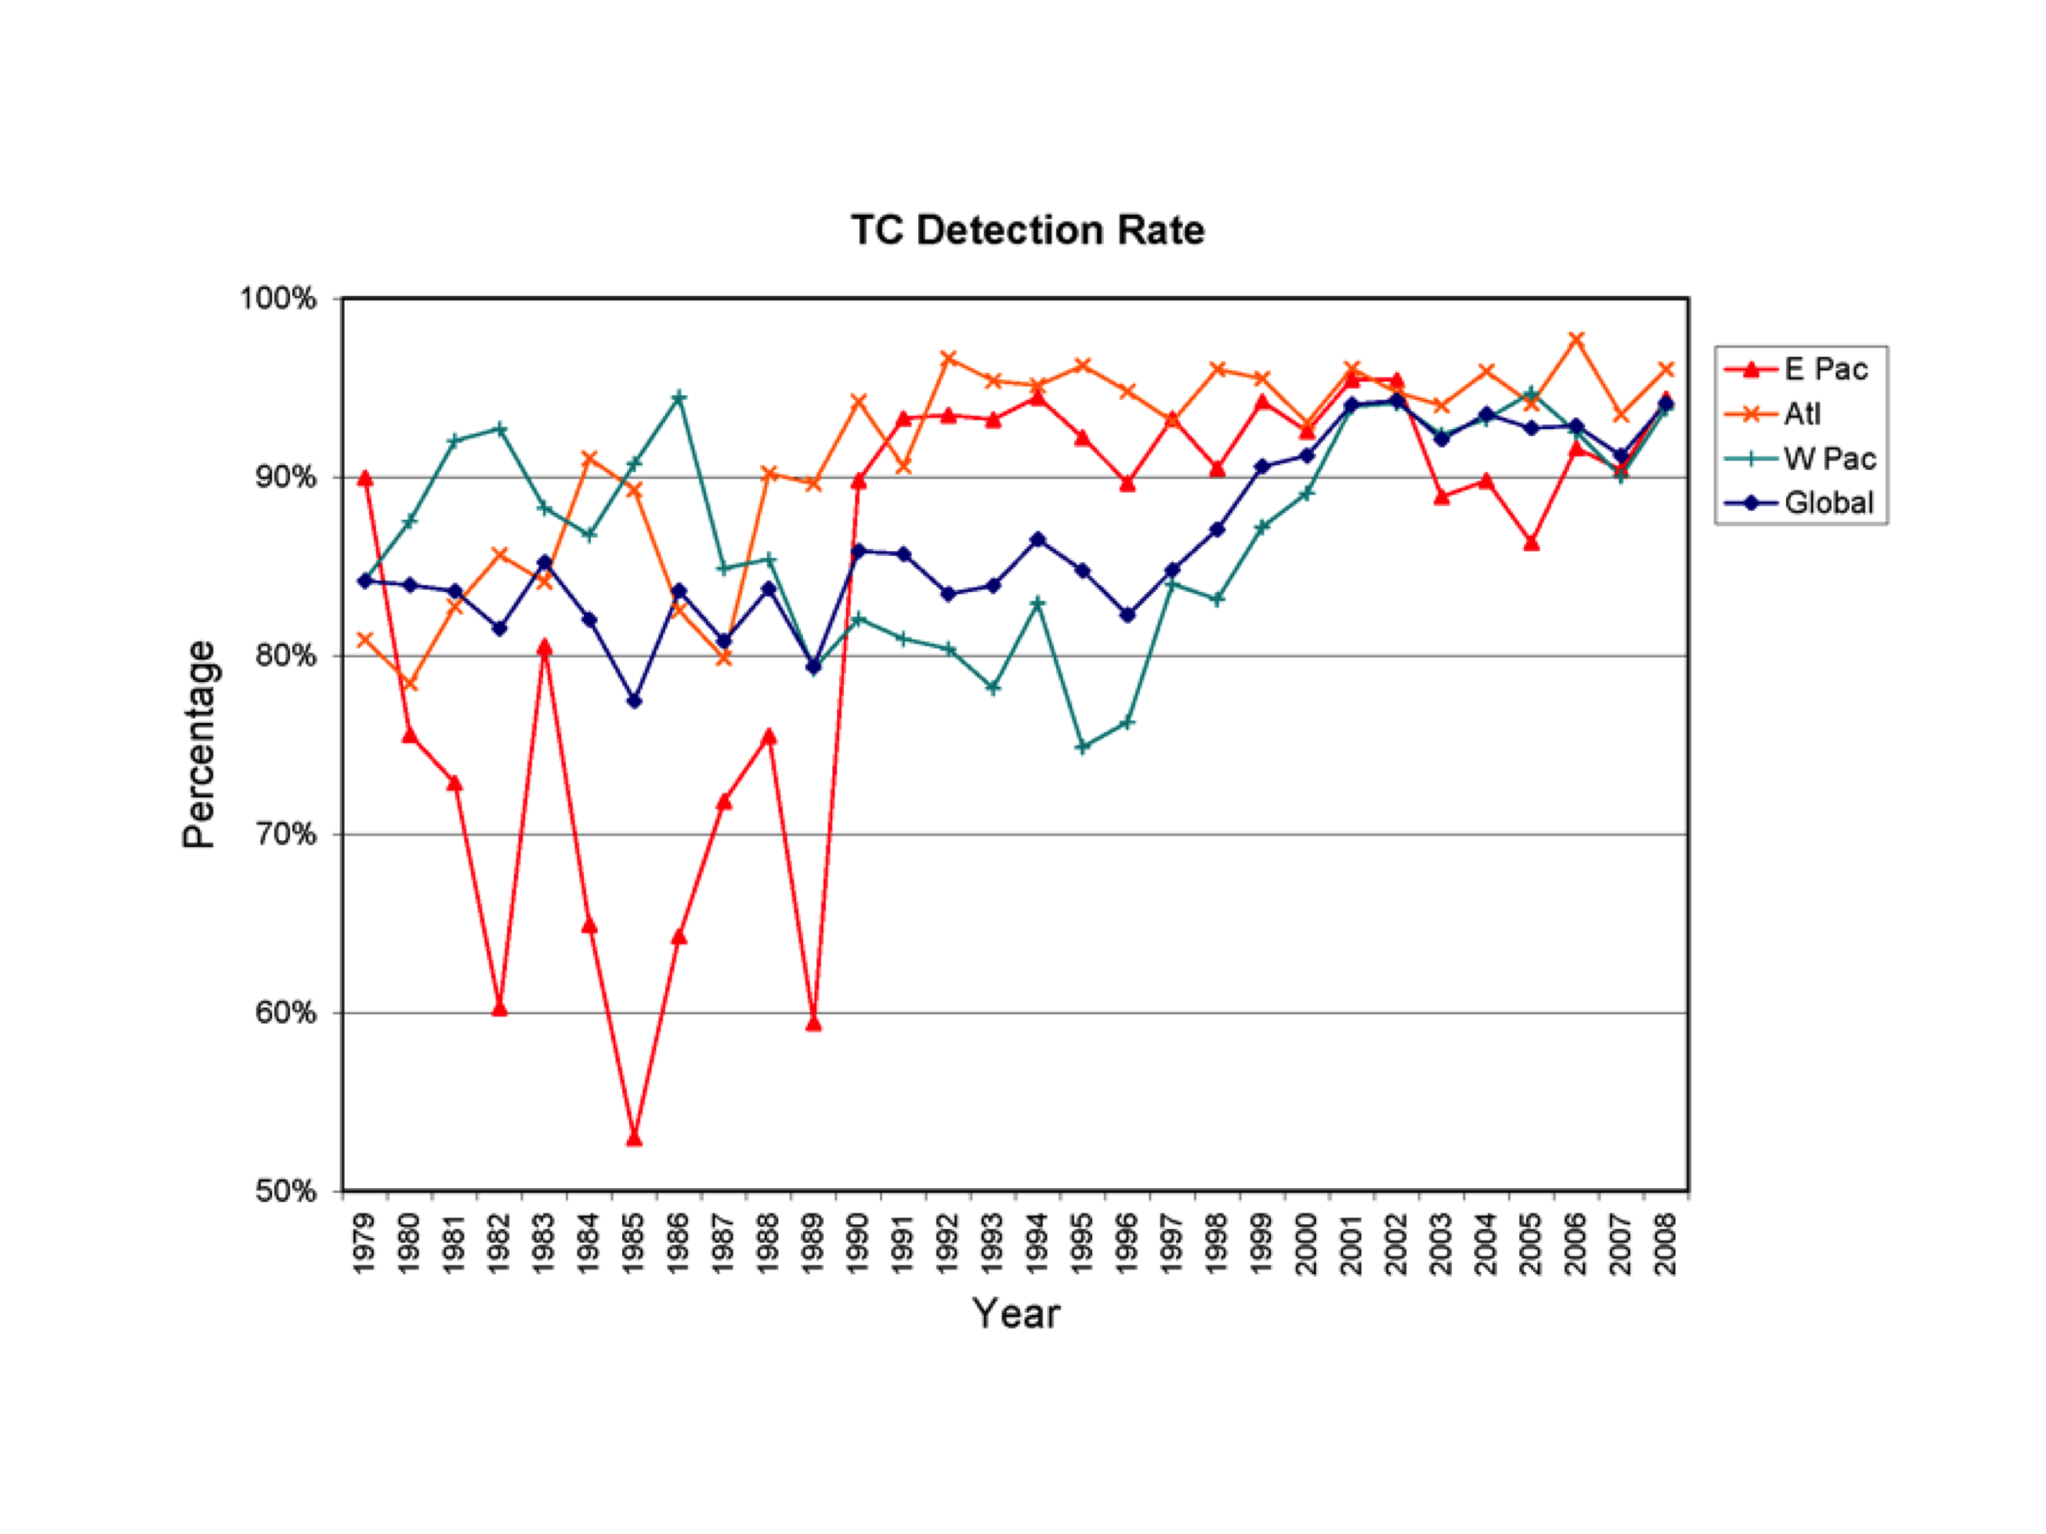
Figure 14: Tropical cyclone detection rate from CFSR.
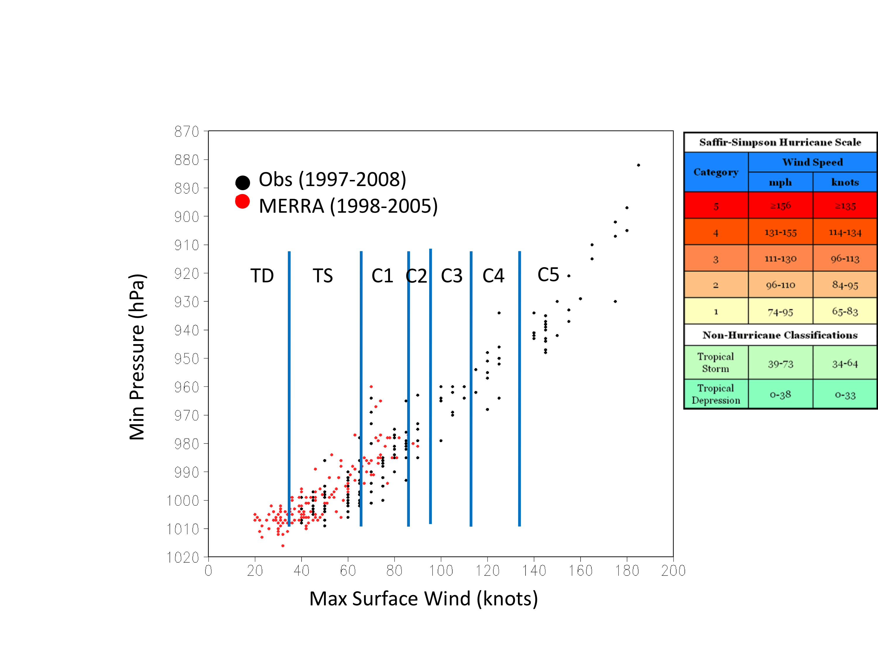
Figure 15: Maximum intensity of tropical storms detected in MERRA over the period 1998-2005, compared with observations from 1997 to 2008.
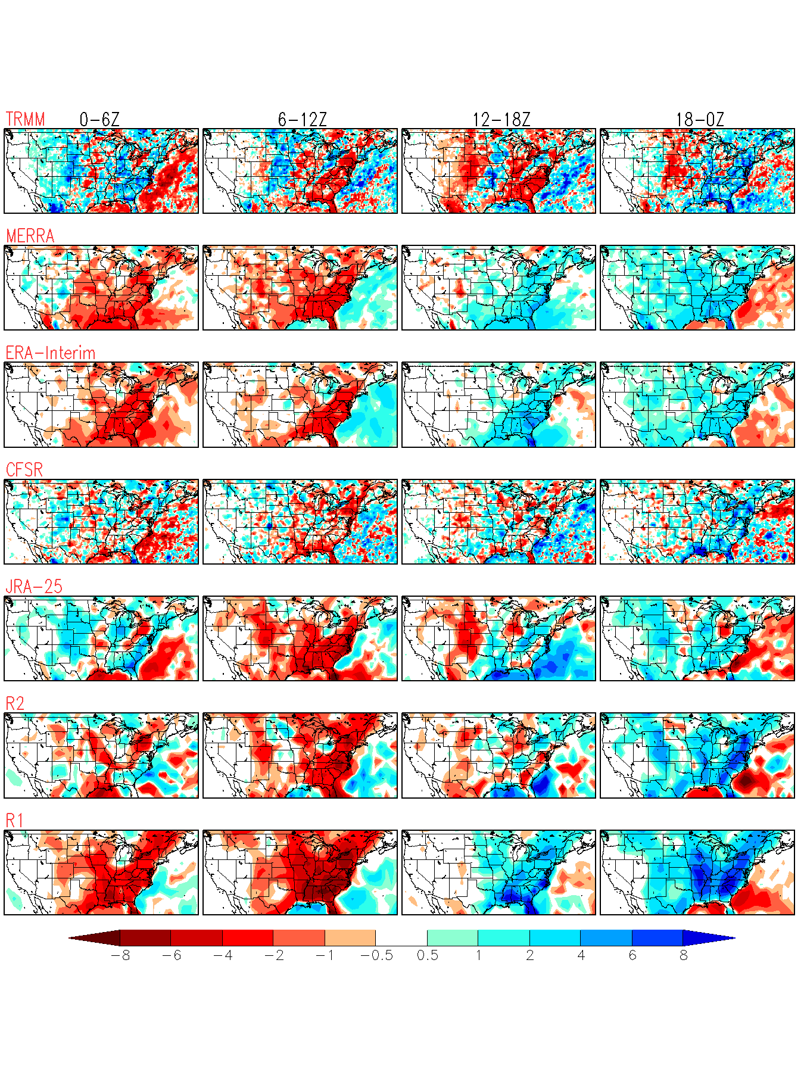
Figure 16: Diurnal variation in precipitation (mm/day) over the United States for July 2004. The July mean has been removed. Results are shown as 6-hour averages for TRMM observations, and for the reanalyses: MERRA, ERA-Interim, NCEP CFSR, JRA-25, NCEP/DOE R2, and NCEP/NCAR R1.
While there has been significant improvement in the representation of variability on time scales shorter than one season, there has been little or no improvement in the representation of the diurnal cycle. For example, while the global distribution of the amplitude of the diurnal cycle in precipitation is generally reasonable, all reanalyses suffer from incorrect phasing, especially during the warm season over land areas where local phenomena such as low level jets and mesoscale convective systems together with complicated/high terrain can play an important role in determining the timing of rainfall (Figure 16). Deficiencies in the diurnal cycle (e.g., the timing of precipitation and clouds) have important impacts on the quality of land hydrology, contributing to unrealistic soil moisture and evaporative fluxes.

The Stratosphere
The dominant components of the climate and variability of the Arctic lower stratosphere were represented quite well in early analyses produced with low model tops (e.g., Pawson and Fiorino, 1998a) since the large-scale structure in this region is sampled by radiosondes. Even in the Antarctic, temperature retrievals from space-based data were adequate to constrain the polar vortex structure, but early analyses do not capture low temperatures characteristic of the polar regions. Increasing the height of the upper boundary led to substantial improvements in the analyzed structure of the middle stratosphere in ERA-40/Interim and GEOS-5 compared to the earlier products. These model improvements coupled with improved use of space-based radiance observations have led to consistent and accurate analyses of the middle and polar latitudes in both hemispheres, up to altitudes of 30-40km.
At higher levels, even the most recent analyses are less successful. Manney et al. (2008) demonstrated that structures in the upper stratosphere and mesosphere are not well captured in analyses performed using systems that assimilate only nadir-sounding radiance observations. It has further been shown that the application of variational bias correction does not work well in the upper stratosphere, where the only data sources are deep-layer radiances from AMSU-A Channel 14 or SSU, and the underlying models typically have large and fast-growing biases. Successful application of variational bias correction relies on the availability of a range of near-independent measurements with different (random) biases and also factors in the model state: this fails in the stratopause region because of persistent systematic model errors and the absence of a range of observations.
In the tropics, the quasi-biennial oscillation (QBO) was captured rather well by ERA-15 but not by NCEP/NCAR R1 (Pawson and Fiorino, 1998b). Reasons for this are not entirely clear, although Gaspari et al. (2006) showed that adequately long length scales are needed to spread wind information from sparse radiosondes around the globe, and that inadequate data selection can readily lead to good observations being rejected in favor of poor analyses in the tropical stratosphere. ERA-40 analyses of the QBO are in excellent agreement with observations, to the extent that these are used as pseudo-observations in the NCEP CFSR. Figure 17 shows that the reanalyses now show very realistic zonal wind variability associated with the QBO. There is less agreement about tropical winds in the upper stratosphere, dominated by half-yearly wind oscillations, where no direct constraints are available and the issues associated with model bias and the availability of deep-layer radiance observations are major factors.

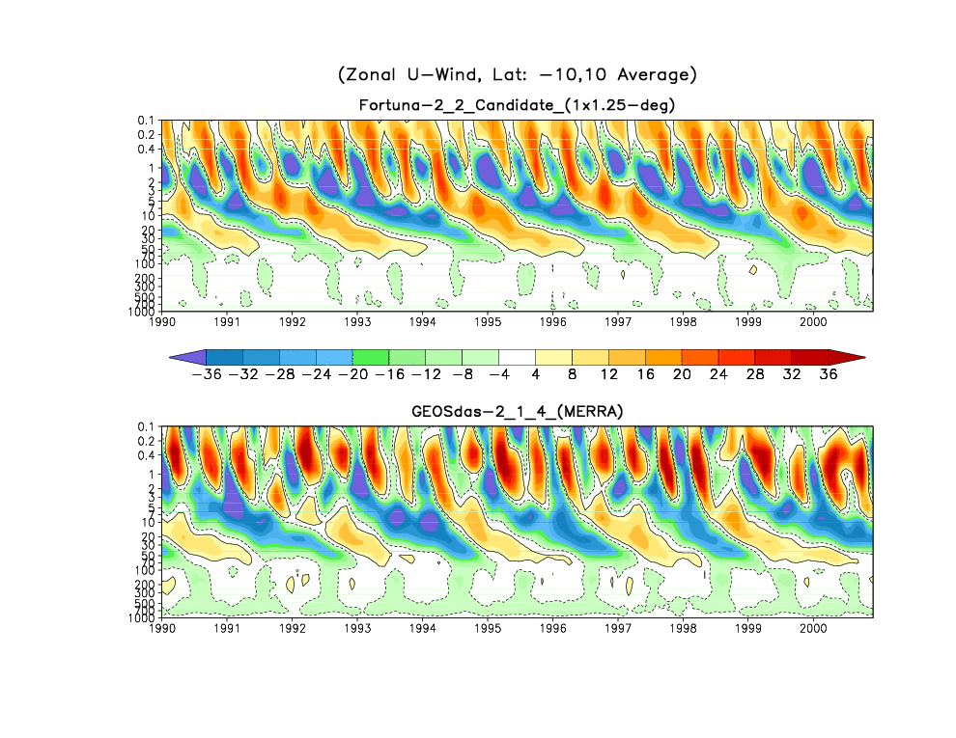
MERRA
ERA-Interim
ERA-40
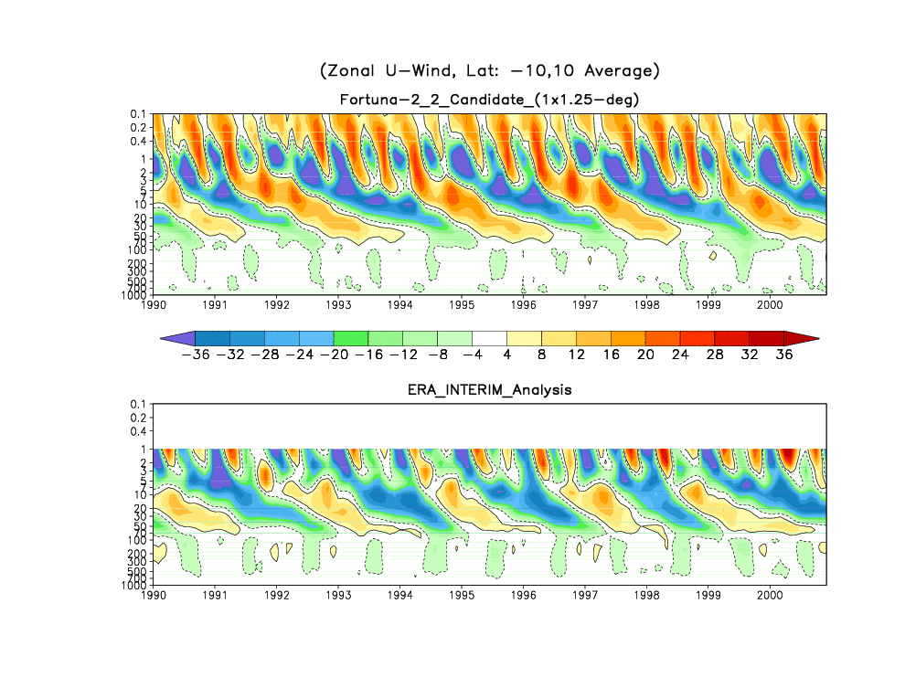
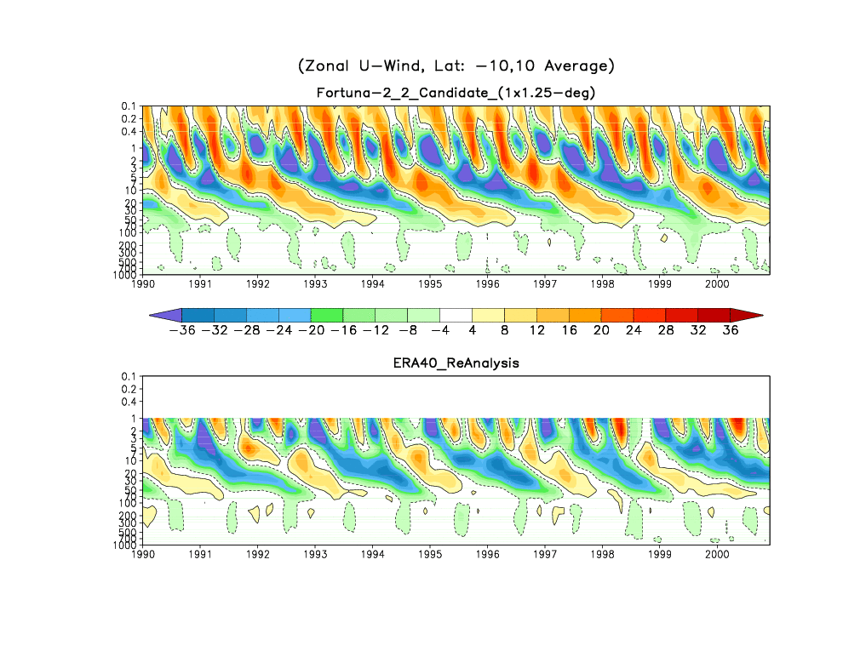
Figure 17: The QBO and SAO from the zonal mean zonal wind component averaged between 10°S and 10°N.
Stratospheric applications of reanalyses include computations of trace gas transport, which are strongly sensitive to the strength and structure of the Brewer-Dobson circulation. Meteorological analyses performed in the 1990s typically showed an over-strong Brewer-Dobson circulation, with excessive tropical ascent and high-latitude descent (e.g., Douglass et al., 1996), leading to unrealistically low (high) values of tropical (polar) ozone columns. In the early 2000s, analyses tended to transport trace gases in an over-dispersive manner (e.g., Schoeberl et al., 2003 or Tan et al., 2004), leading to excessively young mean age of air and unrealistic age spectra. In the middle 2000s, the introduction of time smoothing techniques led to more realistic ozone transport computations and mean age of air distributions (e.g., Pawson et al., 2007). Monge-Sanz et al. (2007) showed successive improvements in stratospheric transport computed from ECMWF analyses that arose from increasing vertical resolution in the stratosphere of the analysis system and ultimately the introduction of 4D-Var, which includes time variations of meteorological fields in the control vector.
Regardless of these improvements in the Brewer-Dobson circulation, the fact remains that stratospheric transport depends crucially on our ability to represent the slow divergent motion in a system where assimilation constraints are imposed at a frequency consistent with synoptic variations and which is optimized to constrain the rotational component of the flow.

Trends and Long-term Variability
All reanalyses are affected by changes in the observing system, especially quantities involving the hydrological cycle (e.g., precipitation and clouds). Such quantities are especially sensitive to changes in moisture data through their impacts on the model convection schemes. Major changes to the observing system – such as the introduction of SSM/I in 1987, AMSU in 1998 and AIRS in 2002 – can produce spurious trends and distort long-term variability. As an example, the time series of global mean precipitation, which is a particularly sensitive measure of changes in the hydrological cycle, shows a number of abrupt changes as well as trends that appear to be linked to changes in the satellite observing system (Figure 18a). The more recent reanalyses, while showing more realistic magnitudes, still suffer from this problem. Interestingly, the “responses” to the observing system changes are very different among the different reanalyses. After the introduction of AMSU-A on NOAA-16, ERA-Interim and MERRA have virtually the same global mean precipitation rate and similar annual cycles. However the time series do not stay synchronized, and, particularly after the demise of AMSU-A on NOAA-16, the two time series depart toward their different pre-NOAA-16 levels. AMSU-A has a strong impact on the annual cycle in MERRA (Figure 19), much more so than in (and in the opposite direction to) CFSR.
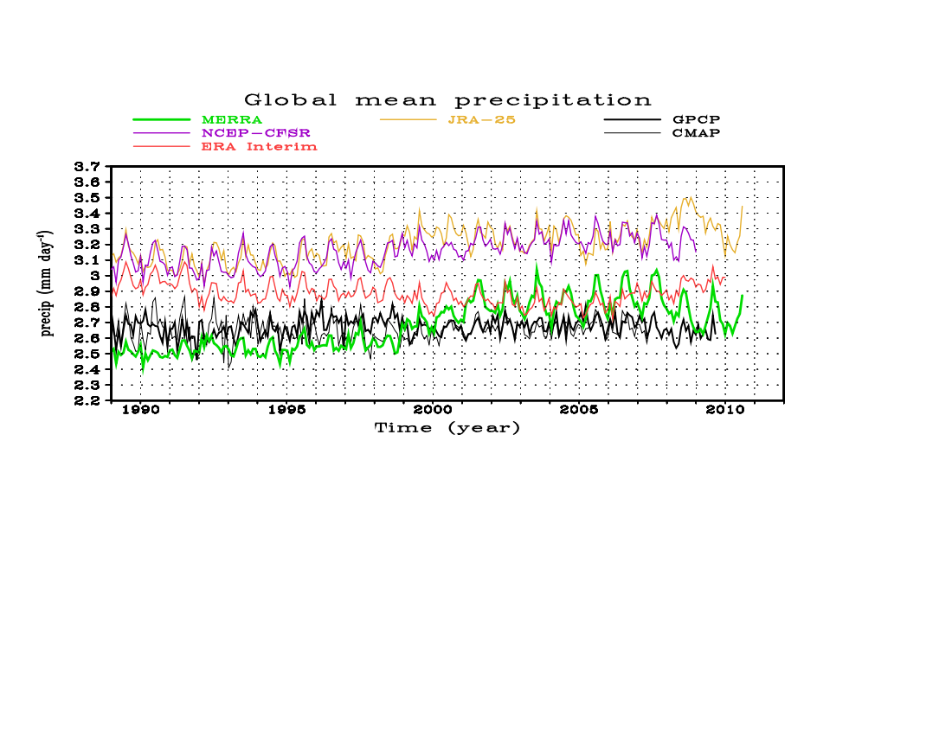
N16
AMSU-A
N16
N15
Figure 18a: Global mean precipitation from the most recent set of reanalyses compared against two observational data sets, GPCP and CMAP. The times of introduction of AMSU-A on NOAA-15 and NOAA-16 are shown, along with the timing of the removal of AMSU-A on NOAA-16 because of instrument failure.
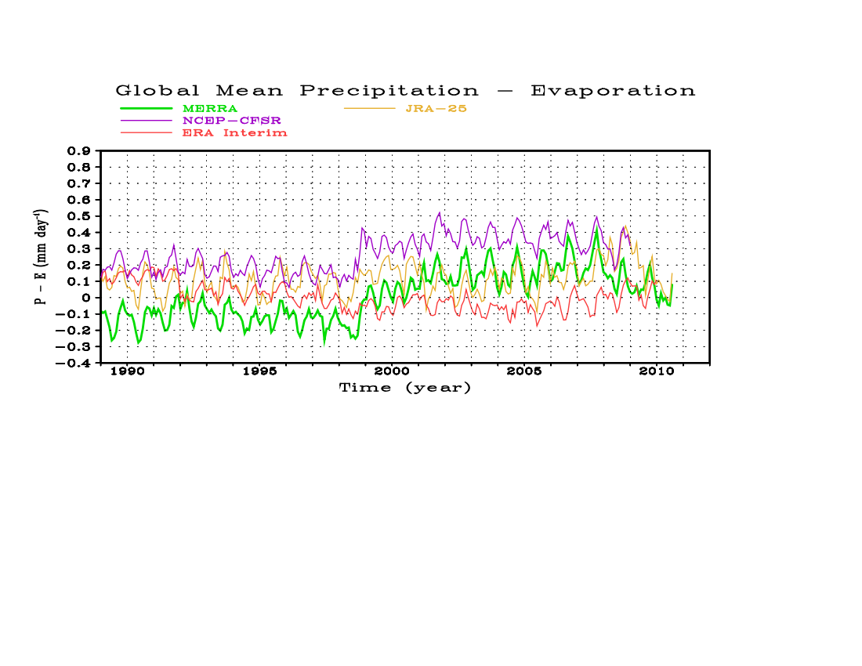

Figure 18b: Global mean analysis increment of moisture inferred from the imbalance between evaporation and precipitation, from ERA-Interim (red), JRA-25 (orange), MERRA (green), and CFSR (purple).
The time series of the inferred analysis increment of moisture (Figure 18b) clearly shows the impact of the changing observing system. The increment in ERA-Interim is smaller than those in the other reanalyses, but still shows changes that coincide with the changes in the availability of AMSU-A. The increments in MERRA and CFSR are very highly correlated although their mean values differ.

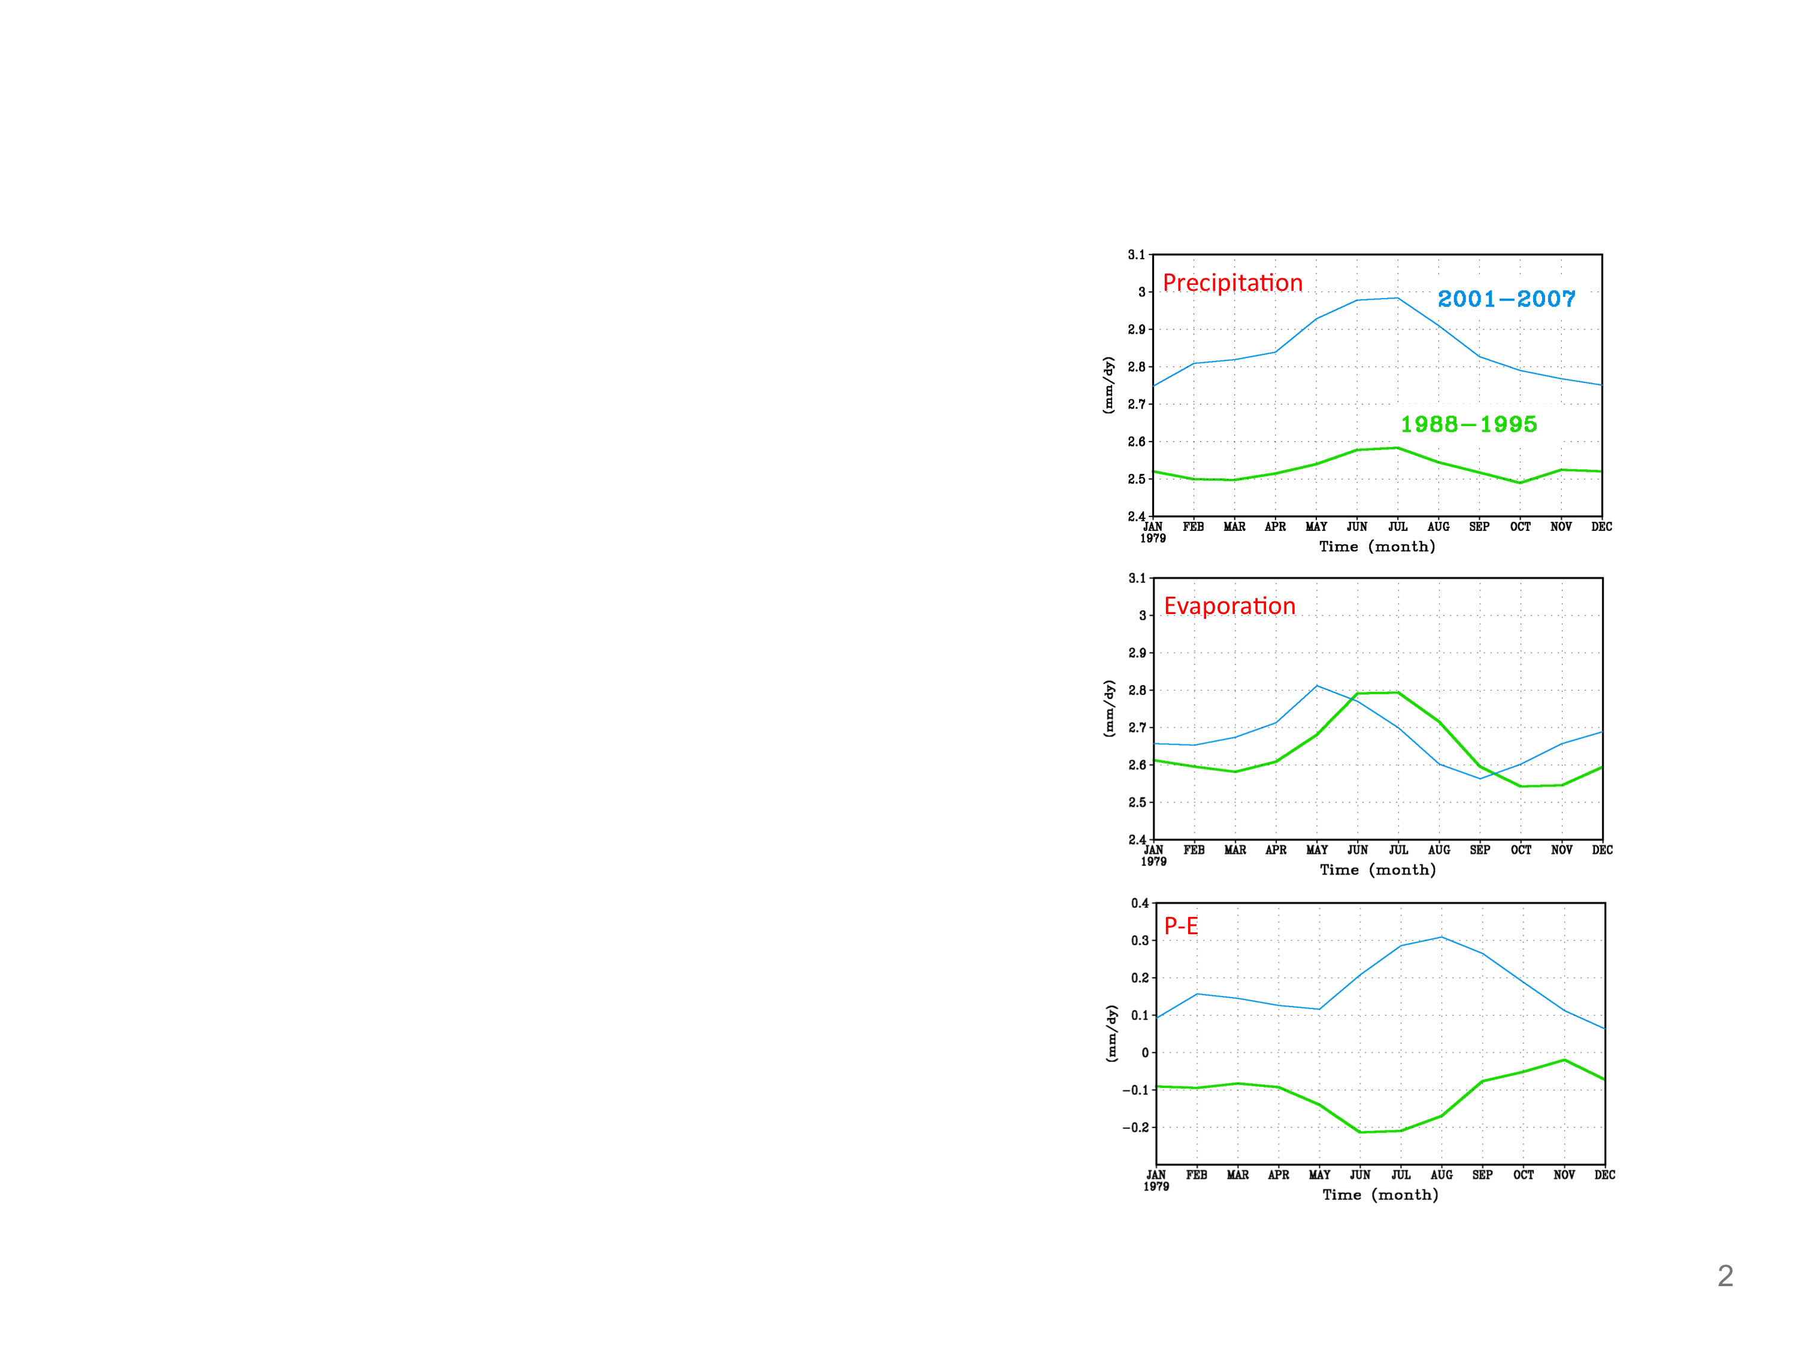
Figure 19: Annual cycle of the global mean precipitation, evaporation, and their difference, from MERRA. The pre-AMSU era is shown in green and the post-AMSU era in cyan.
On the other hand, it appears that some progress has been made regarding trends in surface temperature as a result of improved use of surface observations in the current reanalysis (e.g., Figure 20).
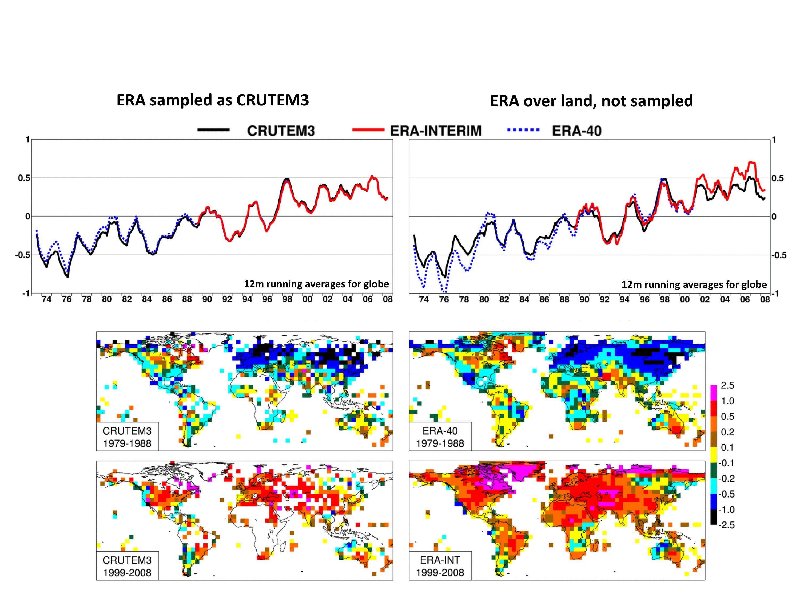
Figure 20: Temperature anomalies at 2m (K) calculated relative to the 1989-1998 mean. The time series from ERA-40 and ERA-Interim are compared against the CRUTEM3 observations (Brohan et al., 2006). The topmost panels are the time series of 12-month running global average anomalies. The top left panel is the time series from anomalies sampled according to availability of CRUTEM3 data (see lower set of panels). The top right panel is from the raw time series.
Figure 21 shows time series of the middle and upper stratospheric monthly temperature anomalies in four reanalyses. All are normalized relative to the mean annual cycle in 1990-1995, a period of relative stability. In the early 1980s all products show evidence of data instability when the first versions of SSU data were available. The two more recent analyses, MERRA and JRA-25 in this case, track each other well at that time, with better stability than ERA-40, but each shows a warm anomaly at 1hPa in 1982-1984. The analyses are more stable between the middle 1980s and about 1998, when the ERA-Interim data also agree quite well. The ERA-Interim and JRA-25 reanalyses show a similar discontinuity in the upper stratospheric temperature when AMSU-A is introduced. (Note: this occurs in 1999 in JRA-25 because we used old JRA files. These figures need to be re-done.) This is indicative of different biases in the AMSU-A Channel 14 radiances compared to the infrared radiances ingested from SSU Channel 3. ERA-Interim and JRA-25 show an upward jump at 1hPa and downward jumps at 3 hPa and 5 hPa, while there is rather less impact in ERA-40. MERRA does not show an obvious SSU-AMSU transition in 1998, as evident in ERA-Interim and JRA-25, but there is some suggestion of anomalous behavior in 2004 when the SSU data streams began to be phased out. (Can we clarify: did Interim and JRA-25 abruptly turn off SSU in 1998 with advent of AMSU-A?) This is a complex issue that needs to be addressed in more detail in future reanalyses: it depends on the presence of model biases and the lack of information on vertical structure inherent in the nadir observations available for reanalysis.
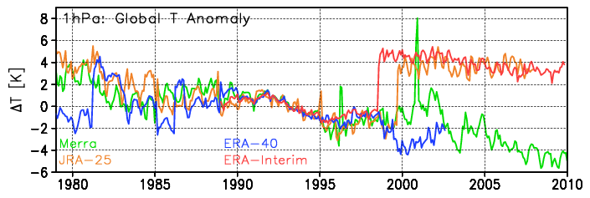
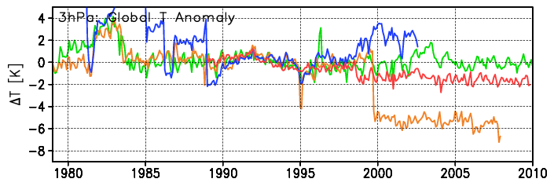
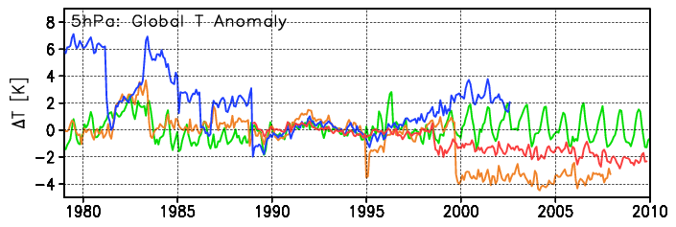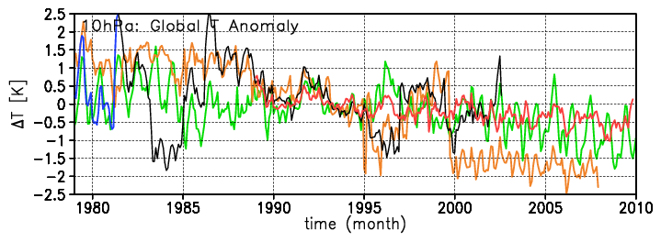
Figure 21: Global mean temperature anomalies (K) in the middle and upper stratosphere from ERA-40 (blue), JRA-25 (orange), MERRA (green), and ERA-Interim (red). Data are shown for 1hPa (top), 3hPa, 5hPa and 10hPa (bottom). The anomalies are computed from the mean annual cycle in 1990-1995 for each individual analysis. (NOTEs: Need to check the peak in Nov 2000 T in MERRA, probably a missing data problem in the averaging. Timing delay in JRA-25 is because of use of old JRA files, figure needs to be redone)

Planning Future Atmospheric Reanalyses
The first generations of reanalyses from NCEP and ECMWF have proven to be extremely valuable scientific tools, enabling climate and weather research not otherwise possible. Their utility stems from the availability of data at regular intervals in time and space, including some variables not easily observed. An important caveat for users, however, is that a reanalysis is not an observation data set, but rather a merged product of model fields and observations. As such, understanding how errors and uncertainties in both models and observations affect the quality of the reanalysis is crucial for gauging its utility as well as the uncertainty in the reanalysis itself.
Significant improvements have come from each generation of reanalyses. Both the improvements and many of the remaining deficiencies are apparent in the (extended) time series of global mean precipitation shown in Figure 22. Most of the improvements have come from the NWP imperative, for which the systems will continue to evolve, taking advantage of new data types and improved methodologies. However, the question remains as to what needs to be done for reanalyses, especially to address jumps and trends associated with changes in the observing system (not including reduced observing systems). Moreover, is it worth undertaking a new reanalysis until the issue of trends can be addressed?
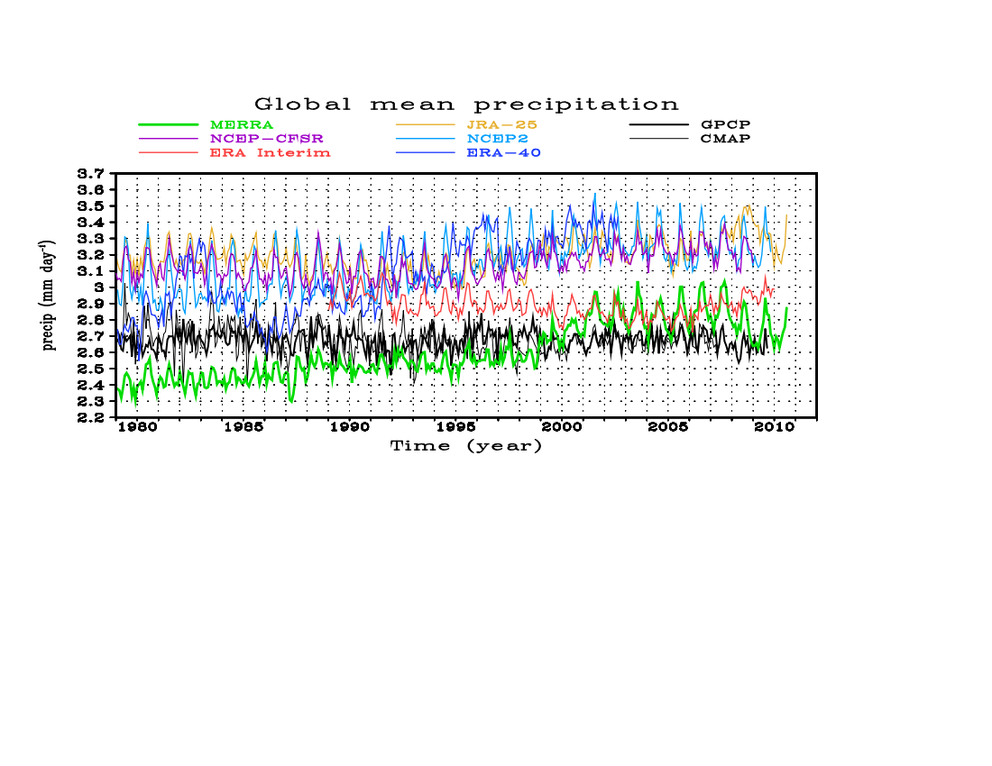
Figure 22: Global mean precipitation (mm/day) for the available reanalyses compared against two observational data sets, GPCP and CMAP.
While agreeing that addressing the issue of artificial trends associated with the changing observing system is a top priority, workshop participants concluded that continuing to update reanalyses is still useful:
- To include improvements in data, using unused data (cloudy radiances, etc)
- To include improvements in models (e.g., reduced biases with resolution)
- As we develop the implementations to help deal with the changing observing system (e.g., changing B with the observing system)
- To provide fields needed for historical re-forecasts for short-term climate
- To make still further major improvements in the water and energy cycle budgets.
The main issues to be addressed for the next generation reanalyses were identified as:
- Improving the hydrological cycle
- Improving the quality of the reanalyses in the stratosphere
- Improving quality of the reanalyses over the polar regions
- Improving estimates of uncertainty
- Reducing spurious trends and jumps
- Reducing the size of the analysis increments

Model
As seen in Figure 18, the “responses” to observing system changes are very different among the different reanalyses. Is this analysis system or model-dependent? What is clear is that correcting model biases will be an important element of reducing both the size of analysis increments and also reducing spurious trends and jumps associated with changes in the input data streams.

Assimilation System
Accounting for changes in the observing system over time is a major challenge for data assimilation in the context of reanalysis, and one that is likely to increase in significance as reanalyses are extended over many decades, and even centuries. While improved models will likely reduce the (often deleterious) effects of observing system changes on reanalysis quality and consistency, data assimilation systems still must be adapted to reflect these changes in terms of the expected accuracy of the background forecast. For example, it is well known that the quality of an analysis produced with a sparse observing system is highly sensitive to the specification of the background error covariances. As noted in section 2, ensemble-based data assimilation systems provide a unique capability in this regard. However, since most centers involved in generating the current- (and, presumably, next-) generation reanalyses will likely continue running some form of variational scheme, strategies for adapting the background error covariances in these systems should be considered.
NCEP, GMAO and ECMWF are developing hybrid variational schemes in which the background error covariances are augmented or replaced by information produced by an ensemble system running in some tandem configuration. The potential benefits of such systems for NWP have already been demonstrated (e.g., Buehner et al., 2010a, b), but it remains to be seen whether such schemes are in regular use by the time the next-generation reanalysis are produced. In the meantime, the JMA has begun its JRA-55 reanalysis using a traditional 4D-Var scheme, but with a simple inflation factor applied to the background error variances during the pre-satellite era. Pre-production tests have shown modest, but noticeable, positive impacts with this technique in terms of fits-to-observations, upper-air analysis errors and forecast skill (..Kobayashi talk at WMODA5, or other reference..).
The effects of model error can also be accounted for (to varying degrees) within the context of the data assimilation scheme. The GMAO has experimented with a variational model bias correction scheme run as part of the minimization—analogous to the variational observation bias correction scheme discussed in section 2—as well as with the application of time-averaged or slowly varying bias estimates (produced by this scheme beforehand) as a forcing term in the model equations (analogous to IAU). Neither approach has produced consistently beneficial results so far, but will likely be re-examined as part of the development effort for the follow-on to MERRA.
Ultimately, a weak-constraint formulation, in which a model error term is added to the analysis cost function, must be employed to produce an optimal analysis. However, specification of the required model error covariance operator (required in the context of 4D-Var) remains a significant stumbling block. ECMWF has experimented with several weak-constraint configurations, representing various levels of approximation to the full four-dimensional problem. A version of weak constraint 4D-Var applied to the stratosphere (without model error cycling) has been running operationally at ECMWF since late 2009 (e.g., Trémolet, 2006) and it is expected that the next reanalysis produced by ECMWF will be run with some form of weak-constraint 4D-Var. The 4D-Var systems under development at GMAO and NCEP are also weak-constraint capable, but have undergone only limited testing to date.
How do we make a reliable measure of uncertainty? Analysis differences?
Gil: something on 20CR ensembles providing one measure of uncertainty.

Observations
Just as source codes for models and data assimilation systems are version-controlled so that changes are traceable, so too is it important to track the quality and release history of observation data sets used for reanalysis. The need for this capability is likely to increase as the number and types of available observations increase and as existing data sets are reprocessed to improve their quality and information content. For example, the Global Space-Based Inter-Calibration System (GSICS) has been established in part to retrospectively re-calibrate a wide range of archived satellite data sets to increase their utility for reanalysis and climate studies. Currently, there is no central data steward for reanalysis input observations, but only some informal sharing of observations and quality information between reanalysis centers. All participants in the workshop agreed that some centralization would be beneficial to future reanalyses, and it was noted that the WCRP Observations and Analyses Panel (WOAP) has initiated a committee to address this issue. So as to maximize the cross-center collaborations, participants agreed that future reanalyses should avoid using proprietary observations or input data sets. In the meantime, the current reanalyses have helped identify biases and trends in currently available satellite and in situ data sets that should be addressed in preparing for future reanalyses.
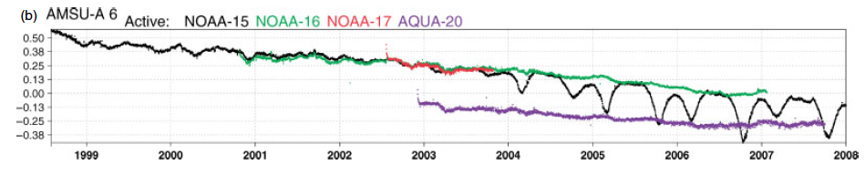
Era-Interim

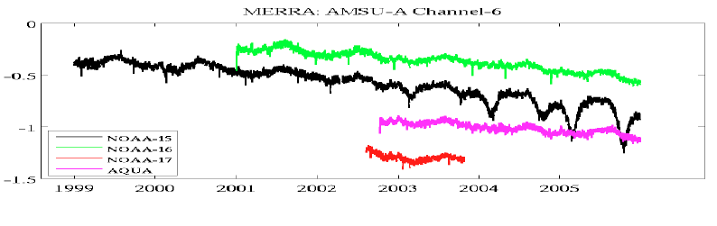
MERRA

Figure 23: Globally averaged bias estimates (K) for AMSU-A channel 6 radiances from NOAA-15, -16, -17 and Aqua based on ERA-Interim (from Dee and Uppala (2009), top) and MERRA (bottom). The bias estimates based on a 12-hourly assimilation cycle in ERA-Interim and a 6-hourly assimilation cycle in MERRA.
DU09 identified a number of such issues by analyzing the performance of the variational bias correction scheme for satellite radiances used in ERA-Interim. Figure 23 shows results from that paper, indicating a long-term trend in the global bias estimates for AMSU-A channel 6 radiances from different satellites, as well as similar results based on MERRA. Both reanalyses show a downward trend as large as 0.5 K per decade, although the bias estimates themselves differ in each system as a result of the different background states and other observational information. Dee and Uppala attributed this trend to known instrument problems, but also noted that the trends may be over-exaggerated in these results due to the assimilation of increasing numbers of (warmly) biased aircraft observations in the upper troposphere. Evidence of the latter is illustrated in Figure 24, which, like Figure 23, compares results from DU09 for ERA-Interim with ones for MERRA, but in this case showing observation-minus-analysis departures and observation counts for aircraft temperature reports at 200 hPa. Note the sharp increase in the number of reports after the late 1990’s, and the corresponding drop in mean departure values as these observations have increasing influence on the analyzed upper tropospheric temperatures.

Figure 24 Missing

Figure 24: Globally analysis departures (K) and observation counts for aircraft temperature reports at 200 hPa based on ERA-Interim (from Dee and Uppala (2009), top) and MERRA (bottom). Observation counts represent 12-hour totals in ERA-Interim and 6-hour totals in MERRA.
These and other results argue for increased focus on data preparation for future reanalyses, especially as a key to improving their utility for studying climate and climate change. Projects such as GSICS are an important first step for improving the quality of existing (and future) satellite data sets in this regard. For conventional observations, the approach so far had been more piecemeal. Off-line bias corrections (Redder et al., 2004) and a “homogenization” procedure (Haimberger, 2007) are applied to some radiosonde observations, and it has been proposed to apply bias corrections to aircraft temperature observations (Balish and Kumar, 2008). Ultimately, however, as with satellite radiances, bias corrections for conventional observations should be estimated within the data assimilation scheme so as to be adaptive and consistent with all other information used in the analysis.
It is also worth noting that most centers make only limited use of surface-sensitive radiance data over land or snow- and ice-covered surfaces that might otherwise be important sources of information in a reanalysis context. In MERRA, for example, microwave radiances from AMSU-A channels 1-6 and 15 were excluded over snow, ice and mixed surfaces, as were radiances from AMSU-B channels 1, 2 and 5, and MSU channels 1 and 2. Surface-sensitive infrared radiances were also excluded over land. Successful use of these data requires, amongst other things, improved modeling of surface emissivity and other relevant land surface characteristics.
The performance of the reanalyses in the high stratosphere is a cause for concern. A major issue is the lack of long-term in situ temperature observations which, coupled with the model biases and the deep weighting functions of the SSU and AMSU-A radiance channels, makes precise constraints on meteorological fields rather difficult to ascertain. It also makes the bias correction inapplicable because of the major contributions of model bias in variational bias correction techniques. Figure 21 illustrates long-term temperature fluctuations that exceed the magnitude of expected decadal trends. Future reanalyses will need to focus on improving models (eliminating model biases) and also better calibrations of the input radiance data and improvement in the way these interact with the background states to produce the analyses. Limb-sounding temperature data are available for certain periods, and may be used as “anchors” for limited numbers of years, but these datasets generally do not overlap, so issues related to cross-dataset bias have not been addressed in detail. High-quality temperature time series are available from occultation measurements, but the extremely low density of these data makes them unsuitable for assimilation: a more promising way of using them in reanalyses will be as calibration datasets – an aspect that will require substantial developments.
Similar arguments apply to ozone analyses, for which the SBUV data provide generally adequate constraints at any time, but issues of cross-calibration of the sensors, due to orbital differences and instrument characteristics, need to be addressed. Again, use of sparse occultation observations for calibration may be promising. Additionally, inclusion of time-dependent greenhouse gases and ozone chemistry in the underlying model will be needed to more realistically represent long-term trends in temperature and ozone in the middle atmosphere.

Anticipated Developments in Coupling to Other Components

Upper ocean and land surface
Many of the questions to be addressed through reanalyses (budgets and exchanges, trends, attribution of major anomalies, etc.) would benefit from consistent analyses across components. Hence there is a lot of interest in integrated Earth System analyses. The NCEP CFSR is the first atmospheric reanalysis conducted where the first guess was provided by the integration of a coupled ocean-atmosphere-sea-ice-land-surface model. It is expected that future developments will have some focus on coupling, whether weakly coupled as in the CSFR or strongly coupled when observations in one component will impact the state in another.
From the comparison of MERRA and CFSR (which both use the GSI analysis scheme) with observations, it is not obvious that there is there a benefit yet to coupling for the quality of the atmospheric reanalyses. However, it is expected that efforts will continue to improve the performance of coupled models, especially of the interface.

Carbon, aerosols, other constituents
The increased interest in “Earth System” reanalyses that include atmospheric composition is based partly on the widespread use of reanalyses for driving atmospheric aerosol, chemistry and carbon models, and also on the increasing availability of observations of atmospheric composition in the past decade. It is reasonable to work towards reanalyses that include atmospheric aerosols, carbon species, and reactive gases, at least for the post-2000 period, as future projects are formulated. Such Earth System components depend fundamentally on the adequacy of the underlying meteorological analyses to constrain aspects such as transport (winds), reactive chemistry (temperature), and emissions of numerous constituents that depend variously upon physical properties such as surface winds (e.g., sea salt, dust, oceanic carbon exchange), surface temperature (e.g., isoprene), soil moisture (CO₂). Additional constraints from space-borne sensors can be included into these analyses, such as leaf-area index (e.g., MODIS) that helps constrain respiration and photosynthesis calculations, burned areas and fire radiant energy (e.g., MODIS) that helps constrain CO, CO₂, black- and organic-carbon aerosol emissions, and additional chemical species, such as NO₂ (e.g., from OMI and GOME), that help constrain air pollution. Inclusion of these additional observations to variously constrain emissions and chemical processes adds complexity to the underlying models used in reanalyses, transporting additional species and computing the interactions among them, and adds additional cost to the analyses (more variables in the state vectors).
While assimilation of these constituents is in essence straightforward, there are presently many uncertainties in the details, such as how to best represent background error covariances (with potential cross-species components and co-variance with temperature and transport). It is also important to realize that the multi-decadal analyses that the community has come to expect for meteorology are highly unlikely to be performed for a broad range of aerosols and constituents because of the dearth of relevant observations over the past decades.

Cross-Center Coordination
The workshop participants agreed that to improve the representation of the climate record in reanalyses, it will be necessary to understand some of the sensitivities and responses of the assimilation systems to the different input data as well as the impact of different input data (such as the use of cross-calibrated MSU vs. using the variational bias correction to account for MSU channel drifts).
An obvious area that needs investigation is the sensitivity of the different systems to the introduction (and removal) of the AMSU-A instruments on NOAA-15 and -16. Each of the systems responds differently, but there is an imprint of change in global precipitation in each of the systems (Fig. 18). Differences may reflect differences in QC measures. For example, developers at NCEP and GMAO cited a potential deficiency in QC for the water vapor sensitive channels (1-5 and 15) on AMSU-A in the GSI used for MERRA as compared to ERA-Interim. Hence the suggestion followed to undertake an in-depth investigation of how these channels were used in the various reanalyses. Another difference between the systems is the assimilation of rain radiances (1d+4d var) in ERA-Interim. This was implemented/modified in ERA-Interim in 1992 and had a noticeable impact on the global precipitation (Figure 18a). This then may lessen the impact of new data on the global precipitation in the ERA-Interim system. Obviously judicious experimentation and comparison may provide insight into the variations that are of concern.
The groups agreed to start a joint project of sensitivity analysis:
- Share information on results from sensitivity experiments
- Examine data utilization, including QC decisions, innovation statistics
- Identify joint experiments to be conducted to elucidate the issue.

To set the stage for future coordination, reanalysis centers are encouraged to prepare and share lists of anomalous behavior or features to help identify how common such anomalies are across the various reanalyses.

Innovative Diagnostics
Given the lack of definitive validation data and the vast array of possible comparisons, the workshop participants encouraged the development of innovative diagnostics. Some examples:
- A useful metric of both quality and uncertainty is the level of variance of one reanalysis explained by another. This should be a standard diagnostic for the various reanalyses.
- Summaries such as the joint frequency distribution of long-wave and short-wave fluxes in Figure 7, developed by Junye Chen, provide a new and efficient view of the quality of the radiative analyses.
- A contextual bias analysis, as developed by Arlindo da Silva, helps to see if different types of observations are providing conflicting information to the analysis.

The workshop participants also proposed the identification of important metrics to assess reanalysis quality, beyond NWP skill.

Standard Intercomparisons and Benchmarks Including Community Involvement
Something from Gil on reanalysis.org??

Coordinating Ancillary Products: Accessible Assimilated Observations and Statistics
Making progress in understanding the (possibly different) sensitivities of the different systems to changes in the observing system, or (for example) identifying any benefits from prior cross-calibration of different satellites, will take a concerted effort at comparing information in the ancillary “data” generated through the process of assimilation: innovations, bias corrections, outcomes of data selection algorithms, cloud detection outcomes, etc. In addition, examination of gridded feedback files and contextual bias analyses should be helpful to understand how the data are impacting the system performance.

Moving Forward

Workshop participants agreed to identify a small group to coordinate such an effort between the centers.
What more can we say?? Identify people to undertake some initial sensitivity experiments? Common diagnostics?

References
Balish and Kumar, 2008:
M. Bosilovich, J. Chen, F. R. Robertson and R. F. Adler, 2008: Evaluation of Global Precipitation in Reanalyses. J. Appl. Meteorol. Climatol., 47, 2279–2299.
Brohan, P., J.J. Kennedy, I. Harris, S.F.B. Tett and P.D. Jones, 2006: Uncertainty estimates in regional and global observed temperature changes: a new dataset from 1850. J. Geophys. Res., 111, D12106, doi:10.1029/2005JD006548.
Buehner
Dee, D.P., and S. Uppala, 2009: Variational bias correction of satellite radiance data in the ERA-Interim reanalysis. Q. J. R. Meteorol. Soc., 135, 1830–1841.
Douglass, A.R., C.J. Weaver, R.B. Rood, and L. Coy, 1996: A three-dimensional simulation of the ozone annual cycle using winds from a data assimilation system, J. Geophys. Res., 101, 1463-1474, doi: 10.1029/95JD02601.
Gaspari, G., S.E. Cohn, J. Guo, and S. Pawson, 2006: Construction and Application of Covariance Functions with Variable Length Fields. Q. J. Roy. Meteorol. Soc., 132, 1815-1838.
G.L. Manney, K. Krueger, S. Pawson, M.J. Schwartz, W.H. Daffer, N.J. Livesey, M.G. Mlynczak, E.E. Remsberg, J.M. Russell III, and J.W. Waters, 2008: The Evolution of the Stratopause During the 2006 Major Warming: Satellite data and Assimilated Meteorological Analyses. J. Geophys. Res., 113, D11115, doi: 10.1029/2007JD009097.
Haimberger, L., 2007: Homogenization of radiosonde temperature time series using innovation statistics. J. Clim., 20, 1377-1403.
Haimberger, L., C. Tavolato, and S. Sperka, 2008: Toward elimination of the warm bias in historic radiosonde temperature records—Some new results from a comprehensive intercomparison of upper-air data. J. Clim., 21, 4587-4606.
Monge-Sanz, B.M., M.P. Chipperfield, A.J. Simmons, and S.M. Uppala, 2007: Mean age of air and transport in a CTM: Comparison of different ECMWF analyses, Geophys. Res. Lett., 34, doi:10.1029/2006GL028515
Pawson, S. and M. Fiorino, 1998: The Tropical Lower Stratosphere in Atmospheric Reanalyses. Part 1: Thermal Structure and the Annual Cycle. Clim. Dyn., 14, 631-644.
Pawson, S. and M. Fiorino, 1998: The Tropical Lower Stratosphere in Atmospheric Reanalyses. Part 2: The Quasi-Biennial Oscillation. Clim. Dyn., 14, 645-658.
Pawson, S., I. Stajner, S.R. Kawa, H. Hayashi, W. Tan, J.E. Nielsen, Z. Zhu, L.-P. Chang, and N.J. Livesey, 2007: Stratospheric Transport Using Six-Hour Averaged Winds from a Data Assimilation System. J. Geophys. Res. 112, D23103, doi:10.1029/2006JD007673.
Redder, C.R., J.K. Luers, and R.E. Eskridge, 2004: Unexplained discontinuity in the U.S. radiosonde temperature data. Part II: Stratosphere. J. Atmos. Oceanic Technol., 21, 1133–1144.
Schoeberl, M.R., A.R. Douglass, Z. Zhu, and S. Pawson, 2003: A Comparison of the Lower Stratospheric Age Spectra Derived from a General Circulation Model and Two Data Assimilation Systems. J. Geophys. Res., 108, DOI 10.1029/2002jd002652.
Tan, W., M.A. Geller, S. Pawson, and A.M. da Silva, 2004: A Case Study of Excessive Subtropical Transport in the Stratosphere of a Data Assimilation System. J. Geophys. Res., 109, D11102 doi:10.1029/2003jd004057.
Trenberth, K., J.T, Fasullo, and J. Kiehl, 2009: Earth’s Global Energy Budget. Bull. Amer. Meteorol. Soc., 90 (3), 311-323.
Trémolet, Y, 2006: Accounting for an imperfect model in 4D-Var. Q. J. Roy. Meteorol. Soc., 132, 2483-2504.
Wheeler, M. and G.N. Kiladis, 1999: Convectively coupled Equatorial Waves: Analysis of clouds and temperature in the wavenumber–frequency domain. J. Atmos. Sci., 56, 374-399.
Zou, C., M.D. Goldberg, Z. Cheng, N.C. Grody, J.T. Sullivan, C. Cao, and D. Tarpley, 2006: Recalibration of microwave sounding unit for climate studies using simultaneous nadir overpasses. J. Geophys. Res., 111, D19114, doi:10.1029/2005JD006798.
Appendix A

A.1 NASA MERRA
The development of the Modern Era Retrospective-analysis for Research and Application (MERRA) began with two primary objectives. It was recognized that various aspects of the hydrologic cycle represented in previous generations of reanalyses were not sufficient for climate and weather study, and MERRA proposed to improve upon the water cycle as a contribution to the science community and reanalysis research. MERRA’s assimilation of the complete satellite era is intended to place observations from NASA’s Earth Observing System satellites in a climate context.
MERRA is based on the GEOS-5 atmospheric data assimilation system, version 5.2.0. The NCEP-GMAO Gridpoint Statistical Interpolation (GSI) analysis is integrated with the GEOS-5 atmospheric model in a six-hour assimilation cycle. At ½° latitude × 2/3° longitude with 72 vertical levels, the spatial resolution of MERRA is finer than previous generation atmospheric reanalyses. MERRA utilizes Incremental Analysis Updates (IAU) that allows for reduced “spin-down” effects by applying the analysis as a tendency term in the governing equations. The observational forcing on the data from the increments is tallied in the output budgets of the model (e.g. water and enthalpy). MERRA provides complete atmospheric budgets that balance, including the analysis terms.
MERRA was processed in three separate streams, each spun-up in two stages: from a two-year analysis at 2° × 2.5° and then a 1-year analysis on the MERRA grid. Streams 1 and 2 were each extended to overlap the next stream to examine the nature of the spin-up as well as predictability/uncertainty. The final MERRA distribution is from the longer streams 1 and 2, so that the distributed streams 2 and 3 have been spun up for 5 and 4 years, respectively, at MERRA resolution.
The MERRA observational suite was based in good part on the observational processing by NCEP. Notable differences include the ERA surface winds, where an older version was used for MERRA, and the SSM/I input data, which came from Goddard (precipitation) and from RSS (radiances and surface winds). The radiosonde data were processed differently (more similar to ERA-Interim processing) and the ERA-40 blacklist was used.
A.2 ECMWF ERA-Interim
A.3 NOAA CFSR
A.4 JMA JRA-25
A.5 NOAA 20CR

Appendix B: Summary of Reanalyses to date

Reanalysis | Organization | Time Span | Resolution | Method | Radiances | VARBC
GEOS-1 | DAO | 3/1985-11/1995 | 2×2.5×14L | OI | No | No
ERA-15 | ECWMF | 1979-1993 | T106L31 | OI | No | No
NCEP/NCAR R1 | NCEP | 1955-present |  | 3D-Var | No | No
NCEP/DOE R1 | NCEP | 1979-present |  | 3D-Var | No | No
ERA-40 | ECMWF | 9/1957-8/2002 | T159L60 | 3D-Var | Yes | No
JRA-25 | JMA | 1979-present |  | 3D-Var | Yes | Yes?
ERA-Interim | ECMWF | 1989-present | T255L60 | 4D-Var | Yes | Yes
MERRA | GMAO | 1979-present | ½ ×2/3×72L | 3D-Var | Yes | Yes
JRA-55 | JMA |  |  | 4D-Var | Yes | Yes
20CR | CIRES |  |  | EnKF | No | No

Appendix C: Acronyms

3D-Var Three-dimensional Variational assimilation
4D-Var Four-dimensional Variational assimilation
20CR (CIRES) Twentieth Century Reanalysis
AGCM Atmospheric General Circulation Model
AIRS Advanced Infra-Red Sounder
AMSU Advanced Microwave Sounding Unit
CCSP (U.S.) Climate Change Science Program
CERES Clouds and the Earth’s Radiant Energy System
CFSR Climate Forecast System Reanalysis
CIRES Cooperative Institute for Research in Environmental Sciences
CMAP CPC Merged Analysis of Precipitation
CPC (NOAA) Climate Prediction Center
DAO Data Assimilation Office
DOE Department of Energy
ECMWF European Center for Medium-range Weather Forecasting
EIG Eastward Inertio-gravity wave
ER Equatorial Rossby wave
GEOS Goddard Earth Observing System
GPCP Global Precipitation Climatology Project
GSI Gridpoint Statistical Interpolation
GSICS Global Space-based Inter-Calibration System
IAU Incremental Analysis Update
JRA Japanese Re-Analysis
JMA Japan Meteorological Agency
MERRA Modern Era Retrospective-analysis for Research and Applications
MJO Madden-Julian Oscillation
MODIS Moderate Resolution Imaging Spectroradiometer
MRG Mixed Rossby-gravity wave
MSU Microwave Sounding Unit (part of TOVS)
NASA National Aeronautics and Space Administration
NCAR National Centers for Atmospheric Research
NCEP National Centers for Environmental Prediction
NESDIS National Environmental Satellite, Data, and Information Service
NOAA National Oceanic and Atmospheric Administration
NWP Numerical Weather Prediction
QBO Quasi-Biennial Oscillation
QC Quality Control
SBUV Solar Backscatter Ultraviolet Spectral Radiometer
SNO Simultaneous Nadir Overpass
SSM/I Special Sensor Microwave Imager
SSU Stratospheric Sounding Unit
TRMM Tropical Rainfall Measuring Mission
VARBC Variational Bias Correction
WCRP World Climate Research Program
WOAP WCRP Observations and Analyses Panel

A caveat is that the observations used for reanalysis are often “cleaned-up” versions of the real-time streams and may include some additional data.

